

FHDQ135S

All in one LED display

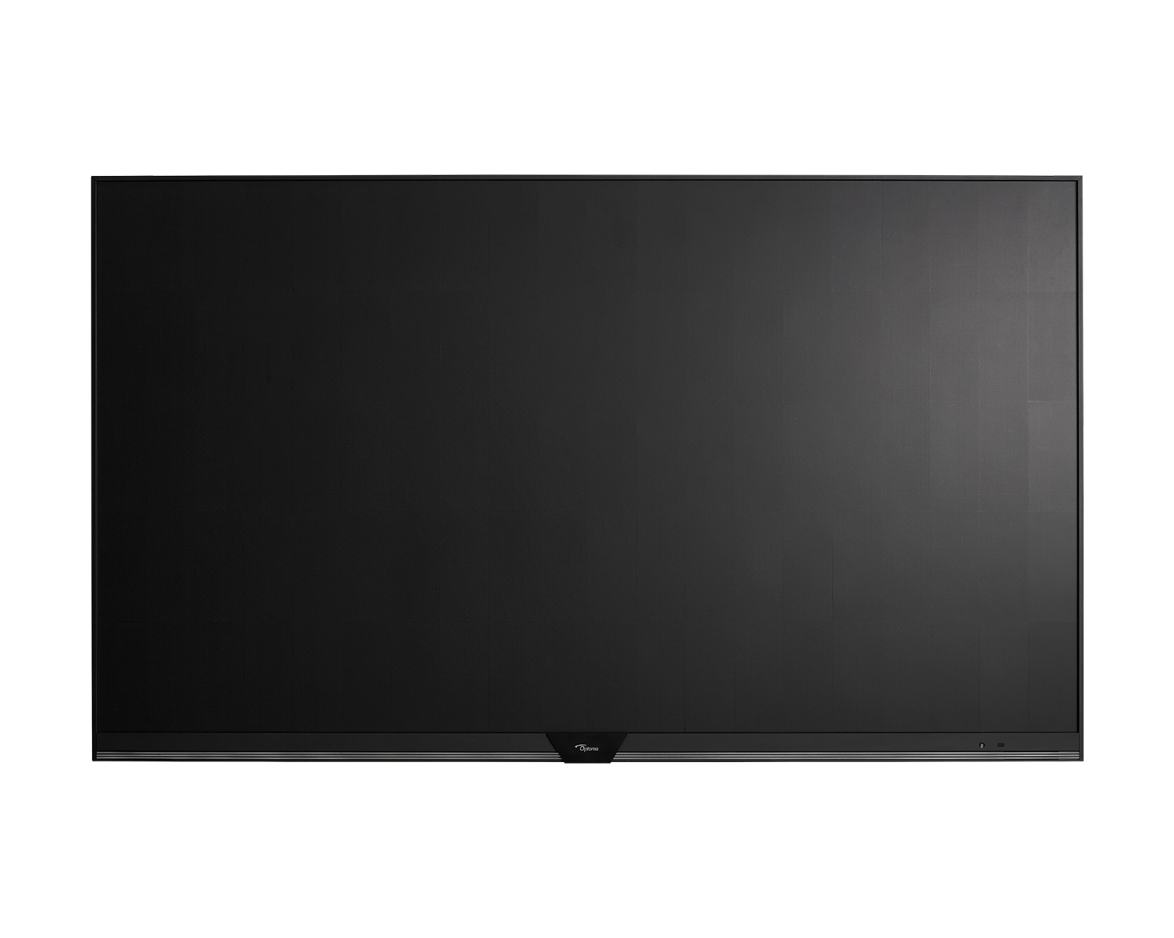

User manual

2024.10
Document version V1.5

TABLE OF CONTENTS

Dear Customer 3
Use Precautions of AIO Products 3
SAFETY 4
Safety Instructions 4
Copyright 5
Disclaimer 5
FCC Statement 5
FCC Warning 5
Declaration of Conformity for EU Countries 6
WEEE 6
Eye Health 6
INTRODUCTION 7
Package Contents 7
Product Overview 10
Remote Control 11
Interface Specifications 12
Electrical 13
USING THE DEVICE 14
Setup Wizard 14
Home Screen Overview 16
BASIC OPERATIONS 17
OSD Menu 17
Android Settings Menu 33
Additional Information 48
Supported Timing List 48
RS232 Protocol Function List 49
LED Indicator 54
Optoma Global Offices 55

Dear Customer
Please read this manual carefully before making any adjustments and retain it for future reference.
Pictures in the manual are for reference only. If any details in this document are unclear, please contact your local representative

Use Precautions of AIO Products
The interior design of AIO LED display screen is very sophisticated, and has no dustproof/waterproof capability. Please follow the precautions during installation and use.
- Screen storage/working environment requirements
  - Storage temperature：-20~40℃；Relative humidity：10%~65%;
  - Working temperature：0~40℃；Relative humidity：10%~80%.
- Installation requirements
  - The installation area of LED display screen is strictly prohibited from leaking or under the air conditioner outlet to avoid damage of LED devices and oxidation of circuit board caused by moisture or condensation. The installation environment humidity must be less than 60% (non-condensation state). It is recommended to install a dehumidifier in the environment to control the humidity.
  - Do not place this screen in these environments as the screen could be susceptible to the following: Metal Dust (which could cause damage to the screen and circuit boards), excessive dust and or dusty conditions (which could affect the screen performance).
- Cleaning requirements
  - During the use of the screen, if there is any accumulation of dust on the surface, it is necessary to use anti-static soft bristle brush or dust-free cloth to clean the screen. Please be careful in the cleaning process to avoid bumping and damaging the LED. Do not use a damp cloth to scrub the screen.

SAFETY
Please follow all warnings, precautions and maintenance as recommended in this user manual.

Safety Instructions
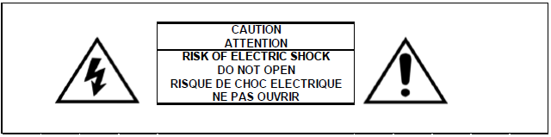
- Always ensure that the unit is properly earthed and power connections are secured correctly.
- Only use attachments/accessories specified by the manufacturer.
- Do not block any ventilation openings. To ensure reliable operation of the device and to protect from overheating, it is recommended to install the device in a location that does not block ventilation. Do not put the device in an enclosure such as a book case or a cabinet that restricts air flow.
- Do not use the device near water or moisture. To reduce the risk of fire and/or electric shock, do not
expose the device to rain or moisture.
- Do not install near heat sources such as radiators, heaters, stoves or any other apparatus, such as
amplifiers, that emits heat.
- Do not let objects or liquids enter the device. They may touch dangerous voltage ports or short out parts
that could result in fire or electric shock.
- Do not place the device on an unstable surface. The device may fall over, resulting in injury or damage to the device.
- Do not setup the device in places where it might be subject to vibration or shock.
- Do not use any hard or sharp object to operate the screen.
- Do not use the device if it has been physically damaged or abused. Physical damage/abuse would be (but not limited to):
  - The device has been dropped.
  - Power supply cord or plug has been damaged.
  - Liquid has been spilled on to the device.
  - The device has been exposed to rain or moisture.
  - Something has fallen in the device or something is loose inside.
- Do not attempt to service the device yourself. Opening or removing covers may expose you to dangerous voltages or other hazards. Please call Optoma before you send the device for repair.
- Disconnect the power plug from AC outlet if the device is not being used for a long period of time.
- Remove the batteries from the remote control before storage. If the batteries are left in the remote for long periods, they may leak.
- Turn off and unplug the power plug from the AC outlet before cleaning the device.
- Use a soft dry cloth with mild detergent to clean the display housing. Do not use abrasive cleaners, waxes or solvents to clean the device.
- See the device enclosure for safety related markings.
- The device should only be repaired by appropriate service personnel.

Copyright
This publication, including all photographs, illustrations and software, is protected under international copyright laws, with all rights reserved. Neither this manual, nor any of the material contained herein, may be reproduced without written consent of the author.
© Copyright 2022

Disclaimer
The information in this document is subject to change without notice. The manufacturer makes no representations or warranties with respect to the contents hereof and specifically disclaims any implied warranties of merchantability or fitness for any particular purpose. The manufacturer reserves the right to revise this publication and to make changes from time to time in the content hereof without obligation of the manufacturer to notify any person of such revision or changes.

FCC Statement
This equipment has been tested and found to comply with the limits for a Class A digital device, pursuant to part 15 of the FCC Rules. These limits are designed to provide reasonable protection against harmful interference in a residential installation.
This equipment generates, uses and can radiate radio frequency energy and, if not installed and used in accordance with the instructions, may cause harmful interference to radio communications. However, there is no guarantee that interference will not occur in a particular installation. If this equipment does cause harmful interference to radio or television reception, which can be determined by turning the equipment off and on, the user is encouraged to try to correct the interference by one or more of the following measures:
- Reorient or relocate the receiving antenna.
- Increase the separation between the equipment and receiver.
- Connect the equipment into an outlet on a circuit different from that to which the receiver is connected.
- Consult the dealer or an experienced radio/TV technician for help.

FCC Warning
This device complies with Part 15 of the FCC Rules. Operation is subject to the following two conditions:
- this device may not cause harmful interference, and
- this device must accept any interference received, including interference that may cause undesired operation.

Notice: Canadian users
This Class A digital apparatus complies with Canadian CAN ICES-3 (B)/NMB-003 (B). Remarque à l'intention des utilisateurs canadiens
Cet appareil numerique de la classe B est conforme a la norme NMB-003 du Canada.

Declaration of Conformity for EU Countries
  - EMC Directive 2014/30/EU (Including amendments)
  - Low Voltage Directive 2014/35/EU

WEEE

Disposal instructions
Do not throw this electronic device into the trash when discarding. To minimize pollution and ensure utmost protection of the global environment, please recycle it.

Eye Health

Calculating Breaks
It is recommended to take a 10-minute break every hour of continuous screen use.
Note: Remember to blink your eyes often to keep them healthy and avoid dryness.

Looking at Distant Objects
During the break look at distant objects or close your eyes. This helps to relax your ciliary (focusing) muscle and avoids eye strain.

How to Exercise Your Eyes?
- Hold your pointer finger a few inches away from your eye.
- Focus on your finger.
- Slowly move your finger away from your face, holding your focus.
- Look away for a moment, into the distance.
- Focus on your outstretched finger and slowly bring it back toward your eye.

INTRODUCTION

Package Contents

Standard Accessories

Item | Description | Photo | Qty.
1 | Tile Removing Tool |  | 1
2 | Wi-Fi USB Dongle  EZC-5201BS | 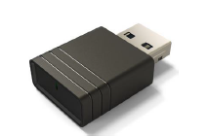 | 1
3 | Infrared Remote Control  *Battery model: CR2025 | 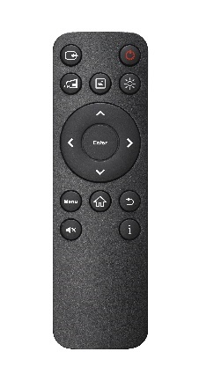 | 1
4 | Left--Wall mount bracket | 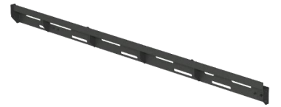 | 2
5 | Right--Wall mount bracket | 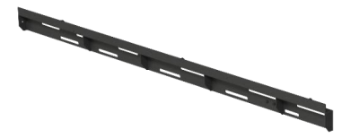 | 2
6 | Left--Frame | 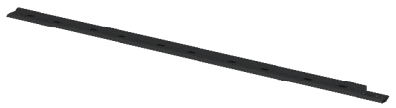 | 1
7 | Right--Frame | 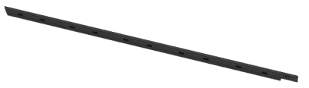 | 1
8 | Top Left--Frame | 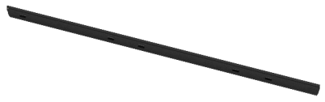 | 1
9 | Top Right Frame | 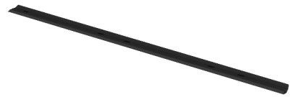 | 1
10 | Logo Fixer | 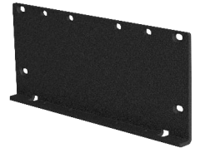 | 1
11 | Cabinet Fixer | 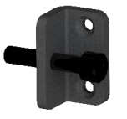 | 8
 | M3*6 Screw with washer | 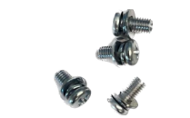 | 26
 | M5*10 Screw | 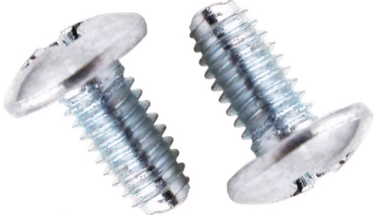 | 7
 | M3*6 Screw |  | 34
 | M4*8 Screw |  | 9
 | M4*10 Screw |  | 18
 | Washer |  | 10
 | M5*25 Screw | 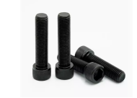 | 18
 | M3*20 Screw | 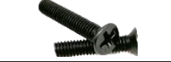 | 2
 | FPC cable (430mm) | 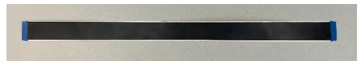 | 3
 | AC Power Cord (EU) | 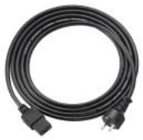 | 1
 | AC Power Cord (UK) | 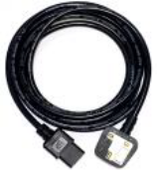 | 1
 | AC Power Cord (USA) | 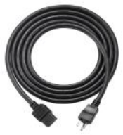 | 1
 | L-shaped hex key 3# | 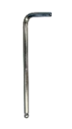 | 1
 | L-shaped hex key 4# |  | 1
 | L-shaped hex key 5# |  | 1
 | Screw driver 1# | 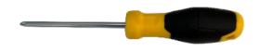 | 1
 | Magnet adjustment tool | 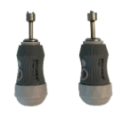 | 2
 | Assist Handle | 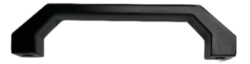 | 2

Note: For warranty information, please visit www.optoma.com.

Spare Parts

Item | Description | Photo | Qty.
1 | LED tile | 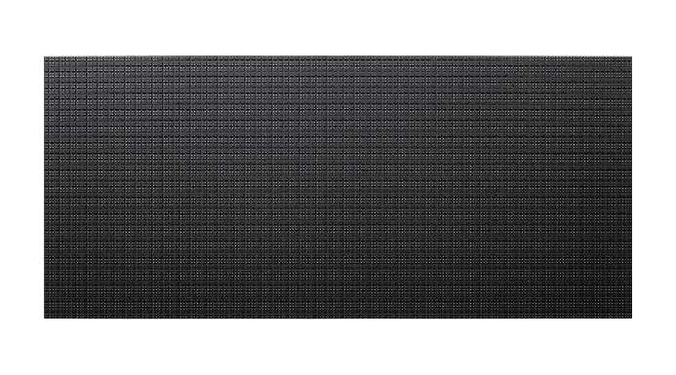 | 4
2 | LEDs |  | 500
3 | LED Driver IC |  | 50

Product Overview

Front View

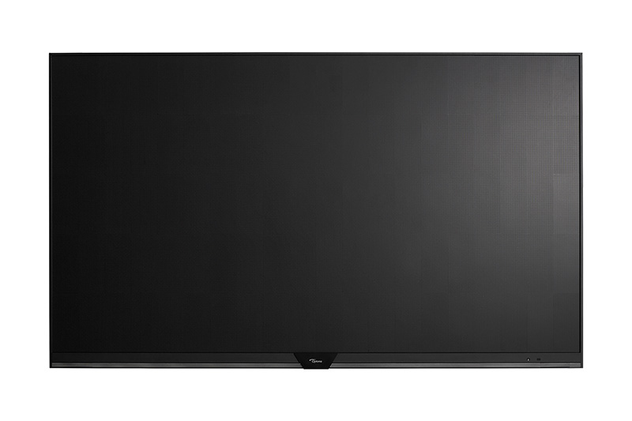

Rear View

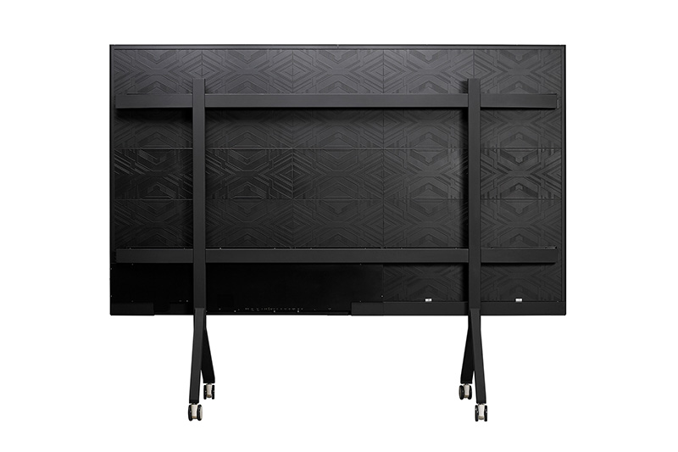

Remote Control
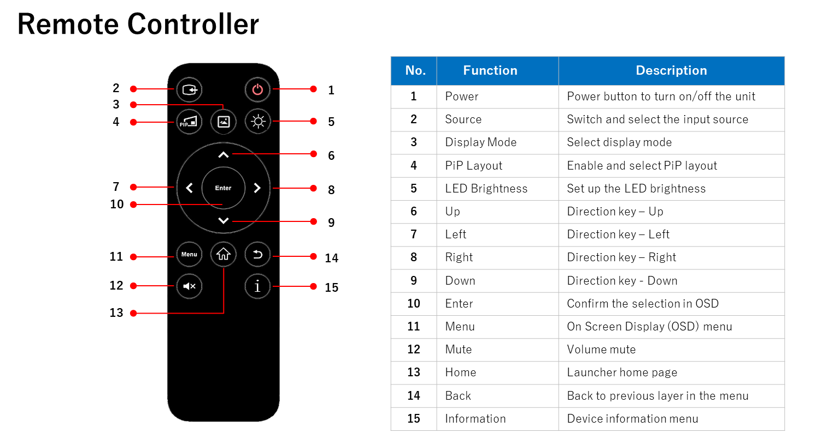

ID | Button | Description
1 | Power button | Power button to turn on/off the unit
2 | Source | Switch and select the input source
3 | Display Mode | Jump to display mode setting
4 | PIP Layout | Jump to PIP layout setting
5 | LED Brightness | Jump to the LED brightness setting
6 | Up | Direction key Up
7 | Left | Direction key Left
8 | Right | Direction key Right
9 | Down | Direction key Down
10 | Enter | Confirm the selection in OSD
11 | Menu | On Screen Display (OSD) menu
12 | Mute | Jump to Volume mute setting
13 | Home | Launcher home page
14 | Back | Back to previous page in the Menu
15 | Information | Device information Menu

*Battery spec: CR2025 Lithium Coin battery 3V

Interface Specifications

Item | Port | IN/OUT | SPEC and Function
1 | LAN | IN | Sender service
2 | HDMI 2 Output | OUT | HDMI: 2.0, 4K output
3 | Power Key | IN | Power On/Off
4 | 3G-SDI | IN | Serial digital Image input (1080p)
5 | HDMI_1 Loop | OUT | HDMI 1 loop through output, 4K
6 | HDMI_1 | IN | HDMI: 2.0, 4K
7 | DP | IN | DP: 1.2a, 4K
8 | HDMI_2 | IN | HDMI: 2.0, 4K
9 | HDMI_3 | IN | HDMI: 2.0, 4K
10 | 3G-SDI | OUT | Genlock support
11 | IR IN | IN | External IR input (3.5mm) TRS
12 | Audio Output | OUT | HIFI stereo Line output (3.5mm) TRS, 2Vrms
13 | USB (Type A) | IN/OUT | USB 3.0 Type A Host for media playback
14 | USB (Type A) | IN/OUT | USB 2.0 Type A OTG for W-Fi dongle or others
15 | LAN | IN/OUT | RJ45 for Telnet
16 | RS232_2 | IN/OUT | Multi-RS232 CLI External Control
17 | RS232_1 | IN/OUT | Multi-RS232 CLI External Control
18 | USB (Type B) | (Reserved) | (Reserved)
19 | USB (Type A) | (Reserved) | (Reserved)

Electrical
Electrical Characteristics for FHDQ135S
At 100V AC Input |  |  |  |  | At 220V AC Input
Parameter | Unit | Rating nom. | Max. | Parameter |  | Unit | Rating nom. | Max.
Input current | A | 6.00 | 15.00 | Input current |  | A | 3.64 | 9.10
Input freq. | Hz | 50 – 60 | 65 | Input freq. |  | Hz | 50 – 60 | 65
Power | VA | 600 | 1500 | Power |  | VA | 800 | 2000

Circuit Protection
Each section of the screen should be protected by a Circuit Breaker to protect against high fault currents, and a Residual Current Device (RCD) to detect earth leakage currents

Earth Leakage Considerations
Each LED display has earth leakage current contributions from twenty-six switched-mode power supplies and a filter. The total earth leakage current per LED display can be up to 26.35mA at 240V. If a 30mA RCD is used, then the maximum number of LED displays per section should be safely limited to 1.

Inrush-current and over-current considerations
The inrush current of the switched mode power supplies used to provide LED and logic power to each LED display is specified by the manufacturer as 1330A at 230volts for a duration of 3mS. However, maximum current in the steady-state for a LED display is considerably less: 12.50A at 240 volts and 15.00A at 200 volts. The circuit breaker used to control a section of the screen must be able to handle the short-term inrush current at switch-on, without causing unnecessary disconnection of the supply, and be able to detect excess currents due to faults within the equipment, during normal operation. 20A Circuit Breaker is recommended.

Earthing
Each LED display is separately connected to the AC power distribution system’s earth through green/yellow wires connection. All exposed metalwork is also connected to this earth.

USING THE DEVICE

Setup Wizard
The Setup Wizard will appear on the screen when you turn on your device for the first time.
Note: This device is equipped with remote control to operate your device.

- Select the language for the on-screen display (OSD) menu. Select Next to continue.
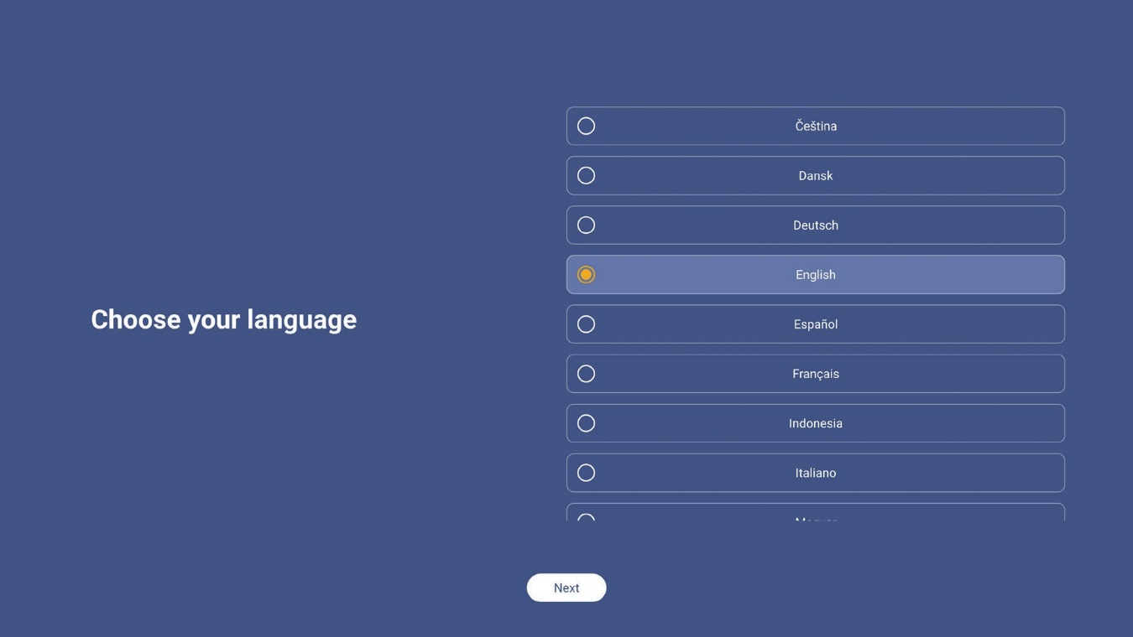

- If you want to connect your device to the Internet wirelessly, select one of the available networks and select Connect. Otherwise, select Skip.

IMPORTANT!
  - To connect to a wireless network, make sure the Wi-Fi dongle is properly plugged into the Wi-Fi dongle slot. Refer to page 12.
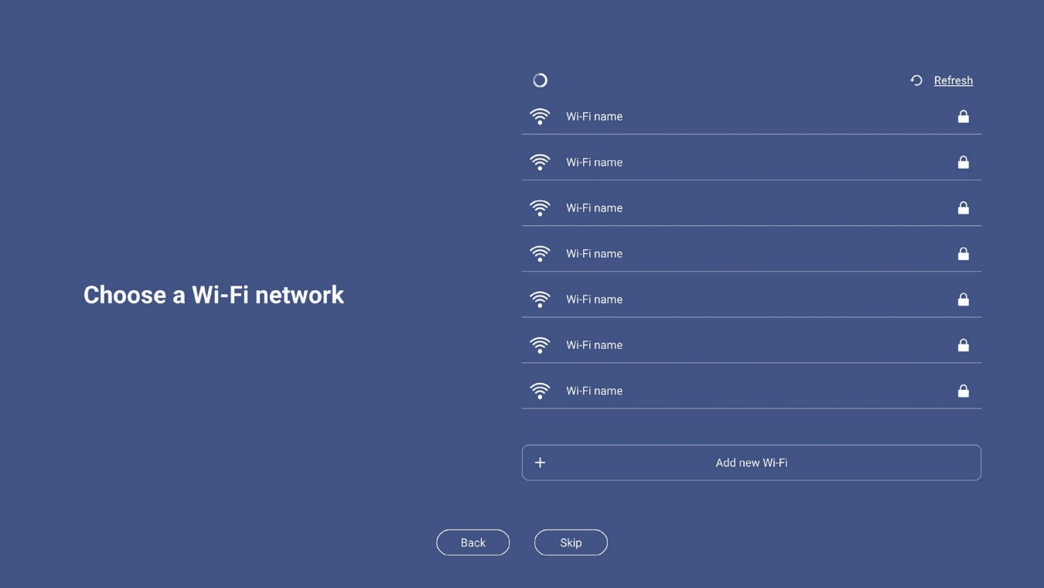
  - If you are connecting to a secure network, you will need to enter the password when connecting for the first time only.

- Configure the date and time related settings. Select Next to continue
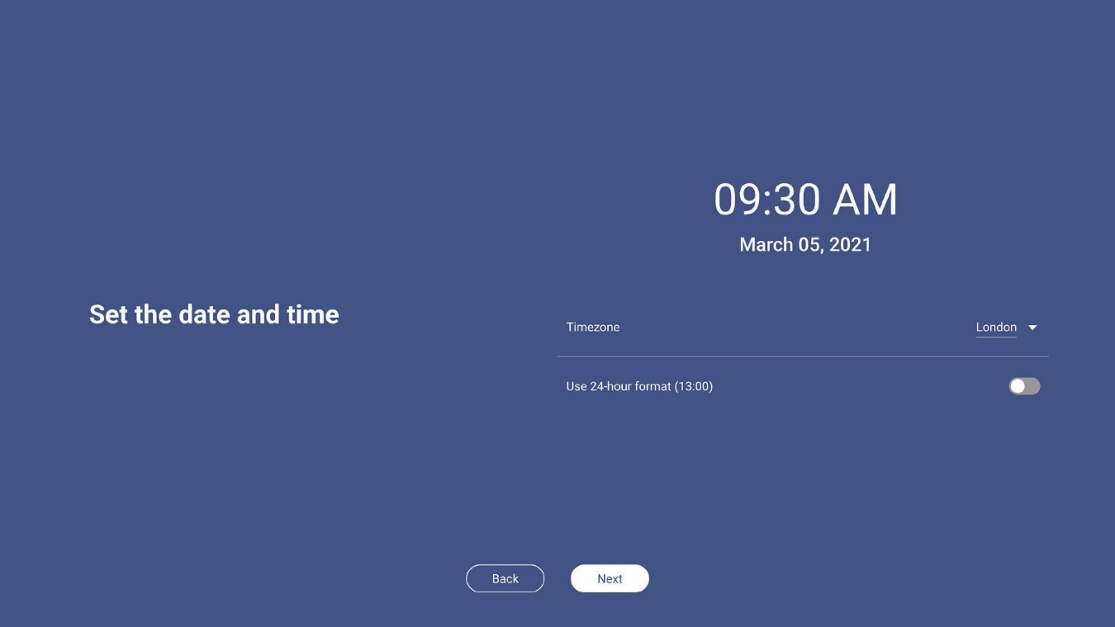
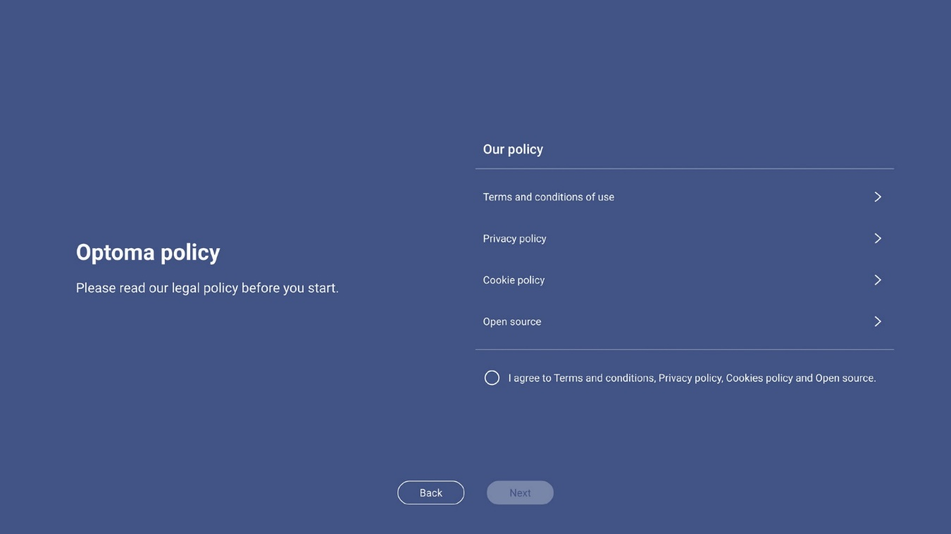
- Read Optoma’s legal policies, including Terms and conditions of use, Privacy policy, Cookie policy, and Open source. Check the I agree to Terms and conditions, Privacy policy, Cookies policy and Open-source radio button and then select Next to complete the setup. The device is now ready to use.

Home Screen Overview
Home screen is displayed every time you start the device.
Sign in to White Board Wireless display
verification code from

Current date and time
Apps shortcuts
Display Share

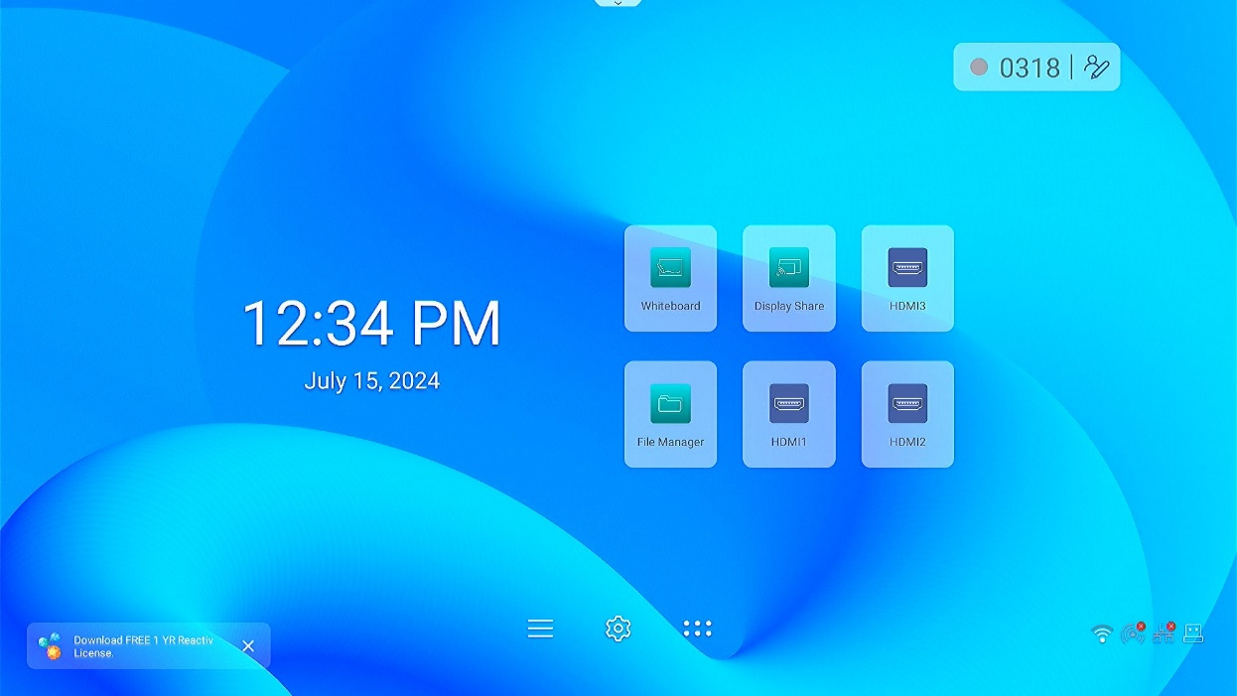

Customizable icons

Apps list
Wi-Fi Hotspot status (only appears when Wi-Fi Hotspot connection is established)
OSD menu
Wi-Fi connection status (only appears when Wi-Fi connection is established)

LAN connection status (only appears when the device is connected to LAN)
Settings
menu
USB flash drive (only appears when the USB flash drive is plugged into the USB port)

OSD Menu
To open the OSD menu, do any of the following

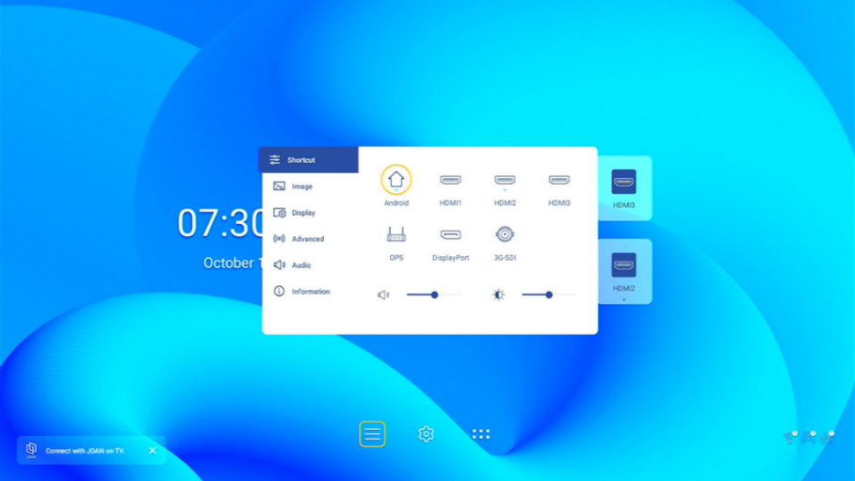

- Press the Menu or Input button on the remote control.
- on the Home screen.
Main menu Submenu Settings
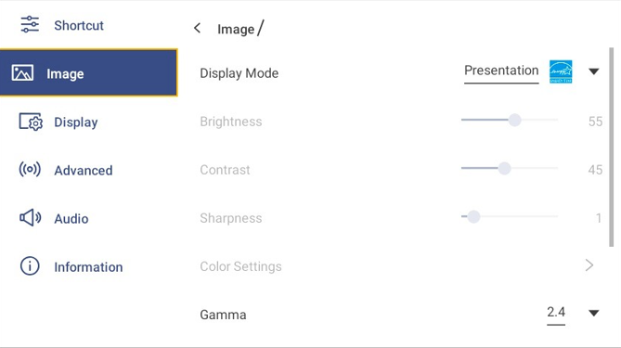
Note:
To configure the OSD menu settings, simply select the menu item on the screen and use the screen controls to adjust its value or set the setting. The selected menu item is highlighted in Blue.
To move to the previous item in the menu, select or press Back on the remote control.
To close the OSD menu, press Back continuously (if necessary) on the remote control.

Shortcut Menu
Shortcut  menu is the first OSD menu.

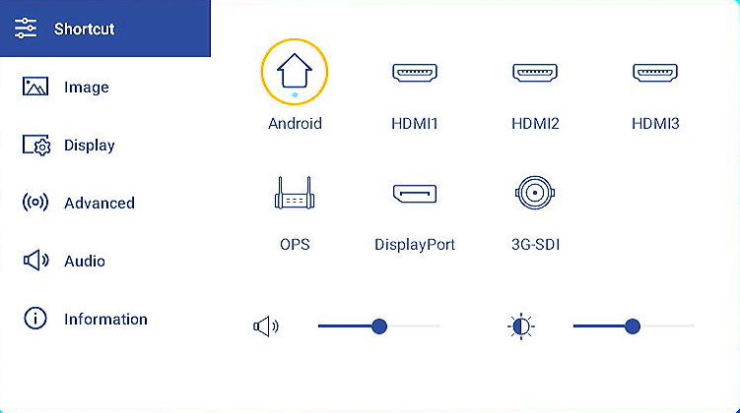
Select the input source. Those input sources that are available are marked with the DOT ● symbol.
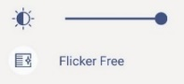
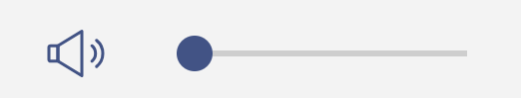
The shortcut page is available to quickly adjust the volume level and LED brightness level.

Menu item | Description | Options | Default
Volume level | Adjusts the volume. | 0 to 100 | 50
LED Brightness level | Adjusts the LED Brightness. | 1 to 100 | 50
Note: The OPS option is only available if the PC module is properly installed into the OPS slot of the device.

Configuring the Image Settings
In the OSD menu, select  to open the Image menu, then complete the following steps:

Display Mode

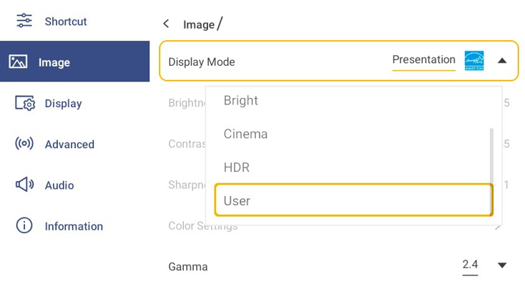

Menu item | Description | Options | Default
Display Mode | Optimizes for displaying images under 4 settings | Presentation  Bright  Cinema  HDR  User | Presentation
Note:
Image settings can only be adjusted in HDMI, 3G-SDI, DP, OPS input. This will be grayed out and cannot be adjusted while in the Android Source.

Gamma and Color Temperature is the setting to select LED gamma, and LED Color Temperature, and can be adjusted in each input and display mode except for HDR mode.

If the Display Mode setting is set to User, you can customize image settings by adjusting the brightness, contrast, sharpness, color space and color settings based on your preferences.

Press slider bar to the right or to the left to adjust the Brightness/ Contrast / Sharpness level
Press the drop down menu to select the Display Mode / Gamma /Color Temperature/ Color Space option

Brightness | Adjusts the intensity of the image. 0 is minimum brightness. 100 is maximum brightness. | 0 to 100 | 50
Contrast | Adjusts the degree of difference between the lightest and darkest parts of the image and changes the amount of black and white in the image | 0 to 100 | 50
Sharpness | Adjusts the sharpness of the image. | 0 to 8 | 0
Gamma | Adjusts the gamma value to obtain a better image contrast for the input. | 1.8/2.0/2.2/2.4 | 2.4
Color Temperature | Adjusts the color temperature to 4 modes. | 3200K 6500K  9300K 12000K | 6500K
Color Space | Sets the color space of the input source of limited range RGB/YUV. | Auto  RGB (0~255)  RGB (16~235)  YUV (0~255)  YUV (16~235) | Auto
Reset | Reset all image setting to default

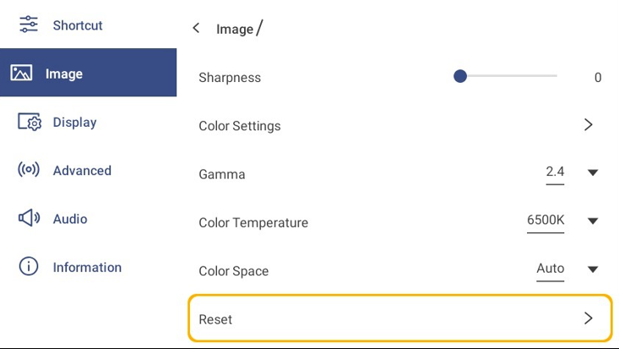

Color Setting

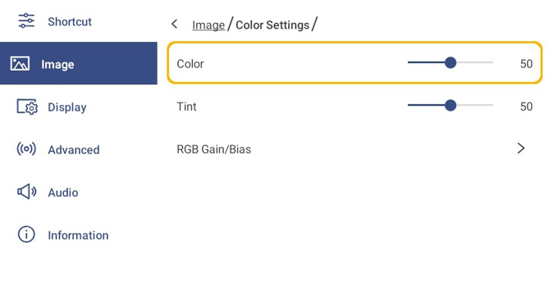

Menu item | Description | Options | Default
Color setting | Use these settings for advanced adjustment of the individual color | Color  Tint  RGB Gain/Bias

Click the bar to adjust the Color/ Tint / Color temperature
Sub- item | Description | Options | Default
Color | Adjusts the color saturation | 0 to 100 | 50
Tint | Adjusts the red-green color balance in the image. | 0 to 100 | 50

Note: Tint level and color level can be adjusted only if the Display Mode is set to User. In other display modes these parameters are preset and cannot be adjusted.

Select RGB Gain/ Bias and to adjust more following settings

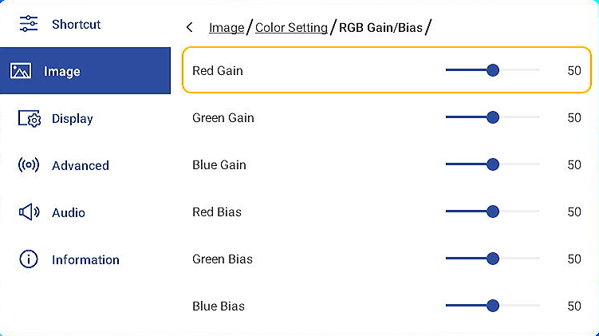

RGB Gain/ Bias | Adjusts RGB Gain and Bias | Red Gain (0~100)  Green Gain (0~100)  Blue Gain (0~100)  Red Bias (0~100)  Green Bias (0~100)  Blue Bias (0~100) | 50
Reset | Reset RGB Gain/ Bias to Default Value

Configuring the Display Settings
In the OSD menu, select  to open the Display menu, then complete the following steps:

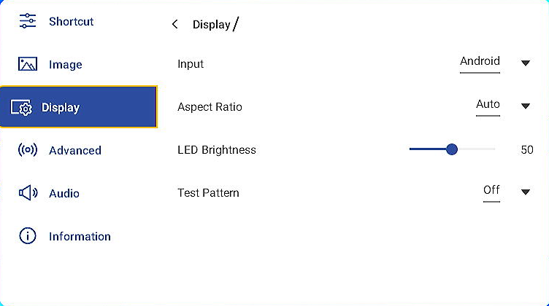

Select Input/Aspect Ratio and select one of the available options, select LED Brightness bar to adjust the brightness level
Menu item | Description | Options | Default
Input | Select an input source | Android  HDMI1  HDMI2  HDMI3  DP  3G-SDI  OPS | Android
Aspect Ratio | Displays an image with the detected size, or  resizes the image by maximizing either the  height, width, both, or resizes to the maximum size possible while keeping the original aspect ratio. | 16:9  4:3  Auto | Auto
LED Brightness | Adjusts the intensity of the LED | 1 to 100 | 50

Press Test Pattern and select one of the available options.

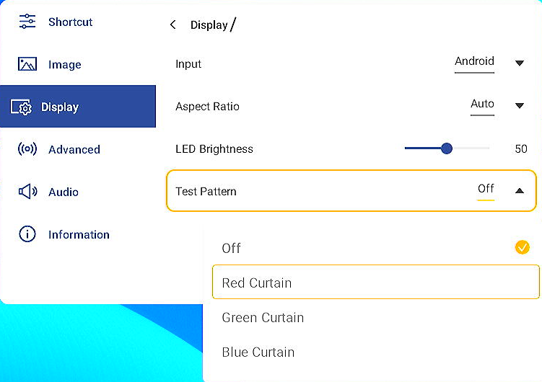

Test Pattern | Displays or hides the test pattern | 0: Off  1: Red Curtain  2: Green Curtain  3: Blue Curtain  4: Black Curtain  5: White Curtain  6: H Ramp  7: V Ramp  8: H Color Bar  9: V Color Bar  10: Checker  11: Grid  12: Slider Bar | Off

Configuring the Advanced Settings
In the OSD menu, press  to open the Advanced setting menu,

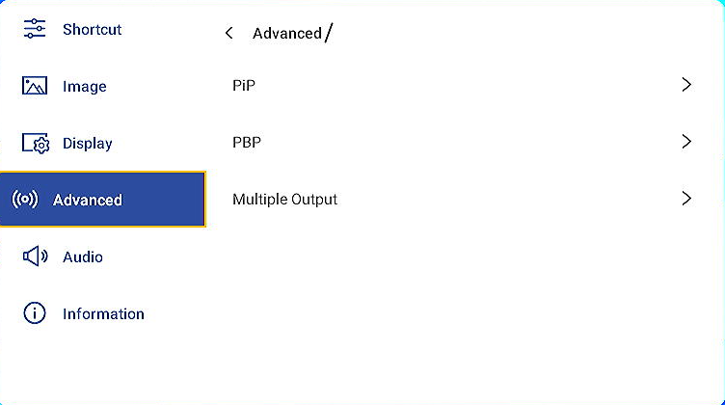

Drag the PIP mode to expand the options Custom 1, Custom 2 and Custom 3

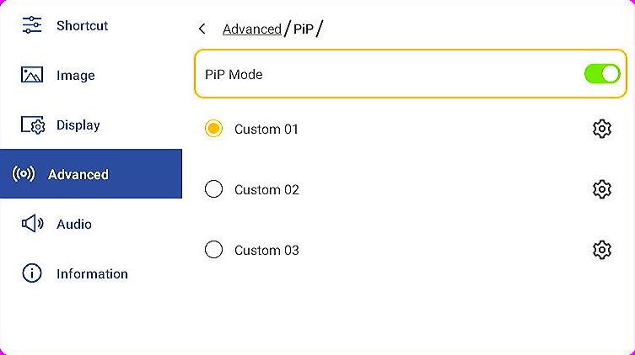
Select Custom 01-03 to set up the following options
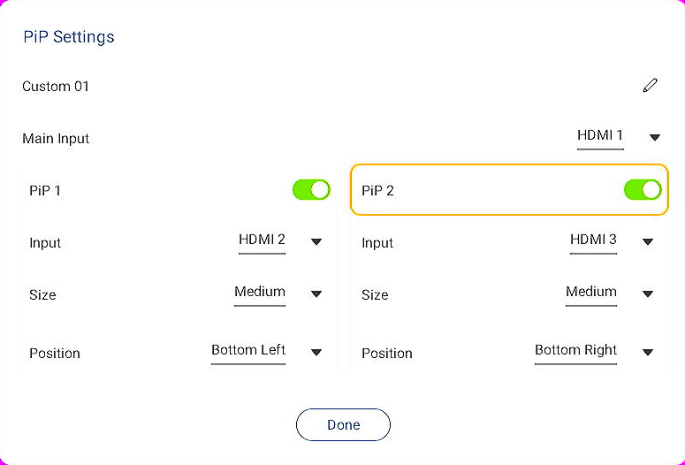
Change PIP Template name by selecting 
Sub- item | Description | Options | Default
Edit Name | Editing name of template and can be applied to custom 01-03. | Custom defined template name
Drag the PIP 1 or PIP 2 to expand the options of PIP 1 or PIP 2

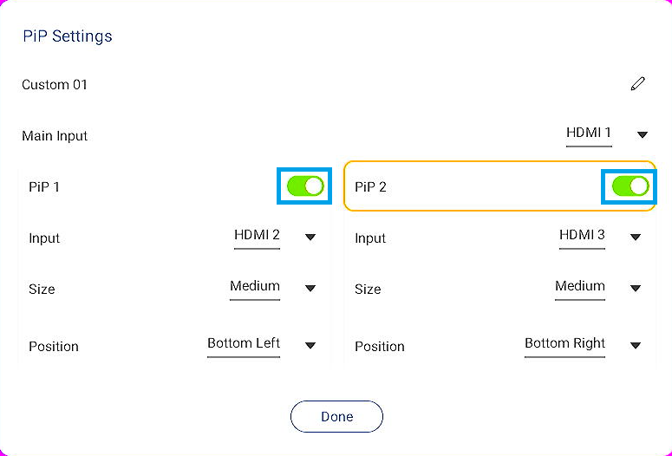

Change settings of Main input/ Input/Size of PIP 1 and PIP 2
Sub- item | Description | Options | Default
Main Input | Main Input | HDMI1  HDMI2  HDMI3  DP  3G-SDI  OPS | HDMI1
Input | Select input source of PIP 1 input or PIP 2 input. | HDMI1  HDMI2  HDMI3  DP  3G-SDI  OPS | HDMI 2(PIP 1)  HDMI 3(PIP2)
Size | Adjust size of the PIP screen | Small  Medium  Large  Custom:  Width: 64-1920 Pixel Height: 64-1080 Pixel | Medium
Note: Select the Width to scroll the value (64-1920) to adjust the image width manually.
Select the Height to scroll the value (64-1080) to adjust the image height manually

Position

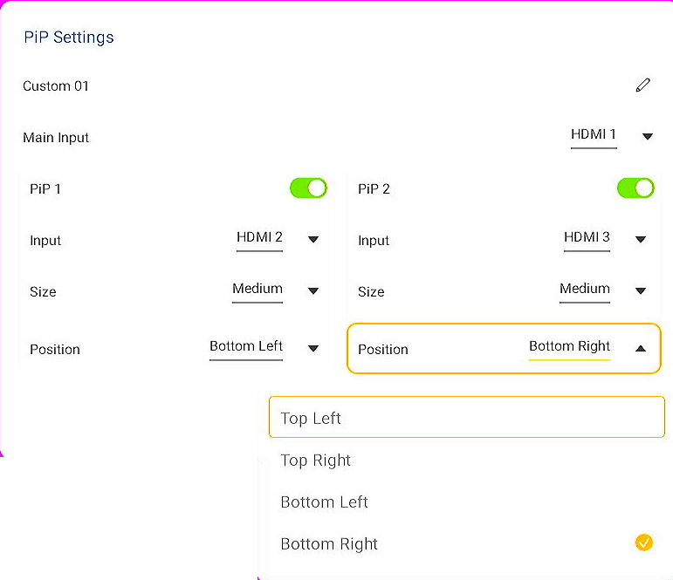

Position | Adjust location of the PIP screen | Top Left  Top Right  Center  Bottom Left  Bottom Right  Custom:  H Position:0-1920 Pixel  V Position:0-1080 Pixel | Bottom Left (PIP1)  Bottom Right (PIP2)
Note: Select the H Position to scroll the value (0-1920) to adjust the image horizontal position manually
Select the V Position to scroll the value (0-1080) to adjust the image vertical position manually

PIP1 and PIP 2 conflict table

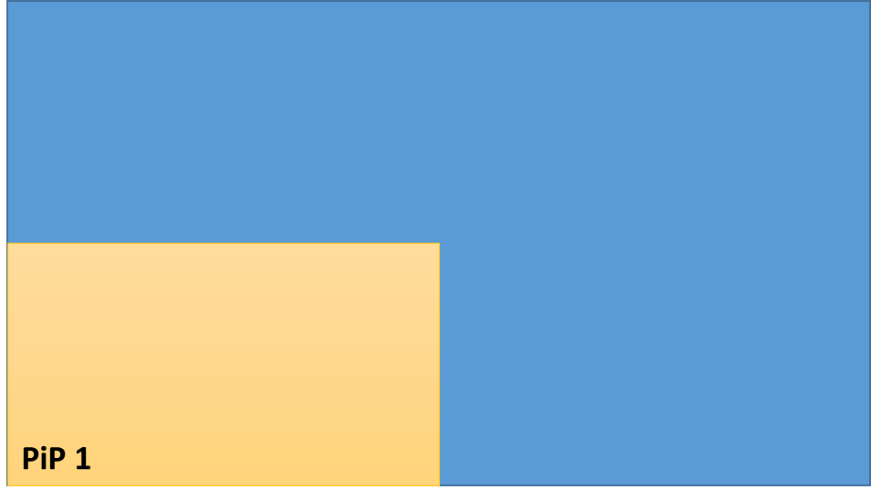  Only PIP 1 | 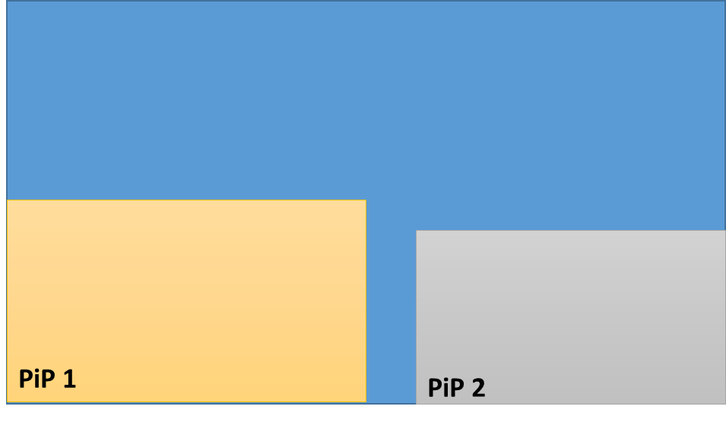  PIP 1 with PIP 2 Bottom Right | 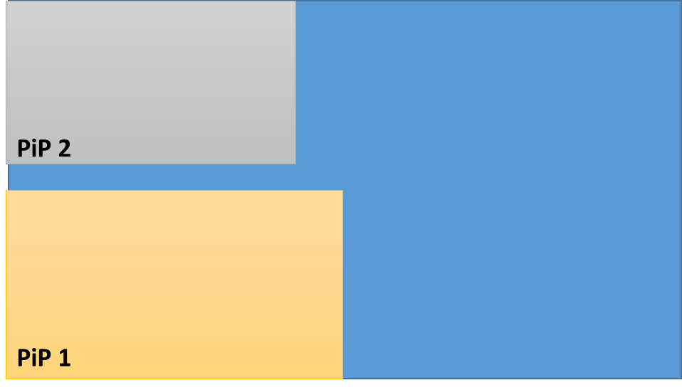  PIP 1 with PIP 2 Top Left
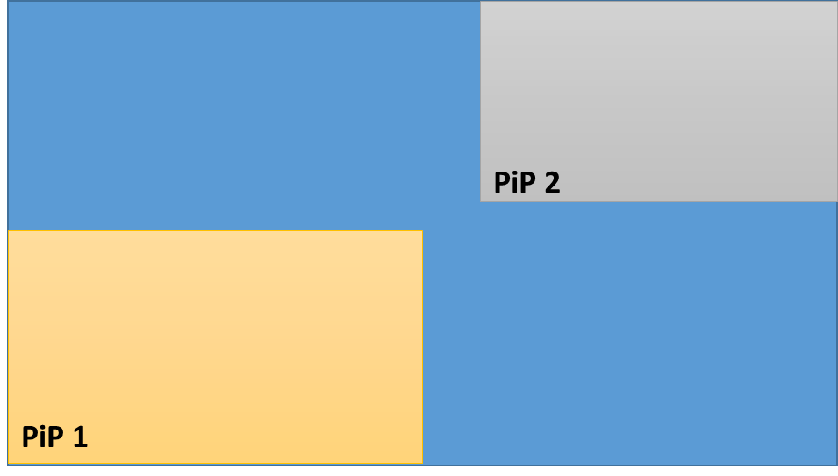  PIP 1 with PIP 2 Top Right | 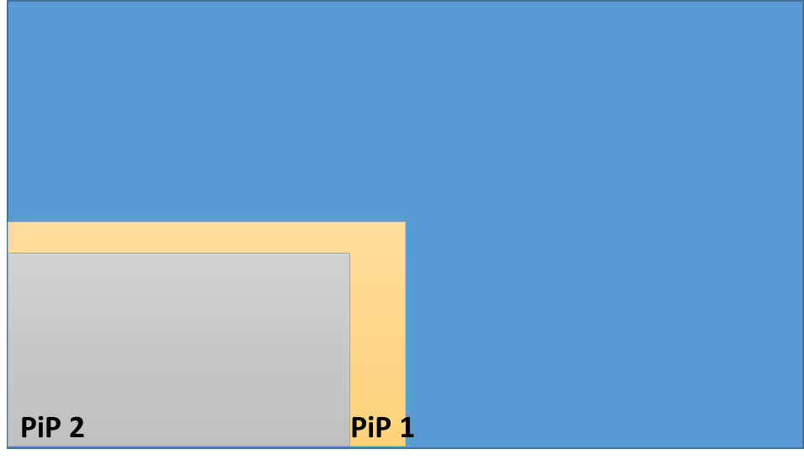  PIP 1 with PIP 2 Bottom Left | 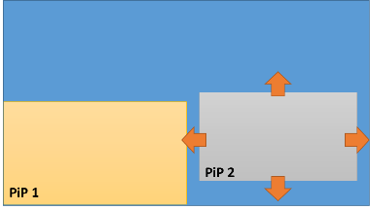  H Position and V Position

User could define PIP 1 or PIP 2 setting first, and choose the location of PIP 1 or PIP 2 shown on the device.
When main input is HDMI 1

Main | HDMI1 | PIP1
Main | HDMI1 | HDMI1 | HDMI2 | DP | 3G-SDI | HDMI3 | OPS
PIP2 | HDMI1
PIP2 | HDMI2
PIP2 | DP
PIP2 | 3G-SDI
PIP2 | HDMI3
PIP2 | OPS

Note:
1. presumed that when setting PIP 1 as HDMI1, then HDMI 1, HDMI 2, DP, HDMI 3, and OPS are available for PIP2.
2. presumed that when setting PIP 1 as HDMI 2, then HDMI 1, HDMI 2, HDMI 3, and OPS are available for PIP2.

When main input is HDMI 2.

Main | HDMI2 | PIP1
Main | HDMI2 | HDMI1 | HDMI2 | DP | 3G-SDI | HDMI3 | OPS
PIP2 | HDMI1
PIP2 | HDMI2
PIP2 | DP
PIP2 | 3G-SDI
PIP2 | HDMI3
PIP2 | OPS

When main input is HDMI 3.

Main | HDMI3 | PIP1
Main | HDMI3 | HDMI1 | HDMI2 | DP | 3G-SDI | HDMI3 | OPS
PIP2 | HDMI1
PIP2 | HDMI2
PIP2 | DP
PIP2 | 3G-SDI
PIP2 | HDMI3
PIP2 | OPS

When main input is OPS

Main | OPS | PIP1
Main | OPS | HDMI1 | HDMI2 | DP | 3G-SDI | HDMI3 | OPS
PIP2 | HDMI1
PIP2 | HDMI2
PIP2 | DP
PIP2 | 3G-SDI
PIP2 | HDMI3
PIP2 | OPS

When main input is DP
Main | DP | PIP1
Main | DP | HDMI1 | HDMI2 | DP | 3G-SDI | HDMI3 | OPS
PIP2 | HDMI1
PIP2 | HDMI2
PIP2 | DP
PIP2 | 3G-SDI
PIP2 | HDMI3
PIP2 | OPS

Note: HDMI 2 is not available in both PIP1 and PIP 2.

When main input is 3G-SDI
Main | 3G-SDI | PIP1
Main | 3G-SDI | HDMI1 | HDMI2 | DP | 3G-SDI | HDMI3 | OPS
PIP2 | HDMI1
PIP2 | HDMI2
PIP2 | DP
PIP2 | 3G-SDI
PIP2 | HDMI3
PIP2 | OPS

PBP Mode (Picture By Picture): Dual Mode(Two Layers) / Triple Mode(Three Layers) / Quad Mode(Four Layers)

User can enable Dual mode/Triple mode or Quad mode and select the input source for each Input. It is the source of PBP layers
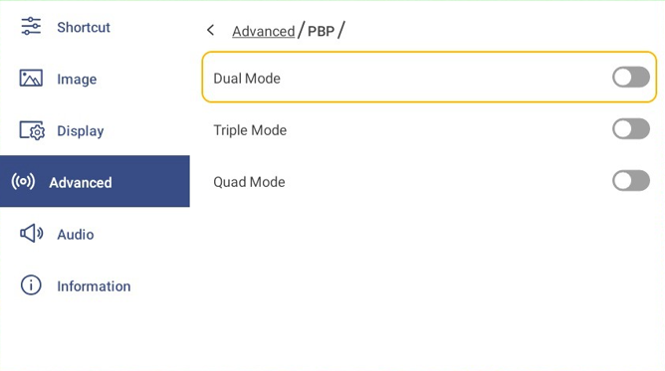
Note: If the input source conflict with higher layers, it will output black screen

Select Dual Mode layouts:
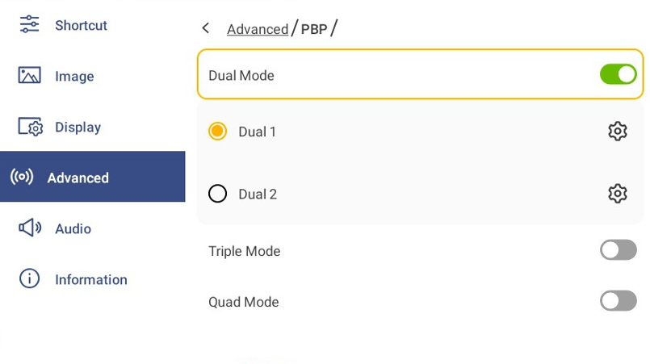

Select Input source for current selected layout of dual mode:
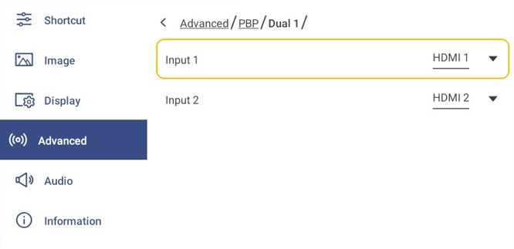

Select Triple Mode layouts:
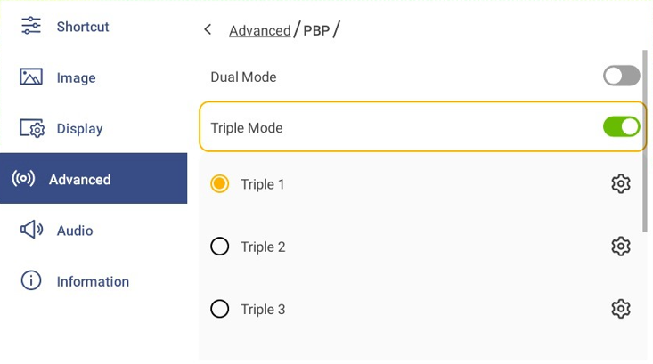
Select Input source for current selected layout of Triple Mode:
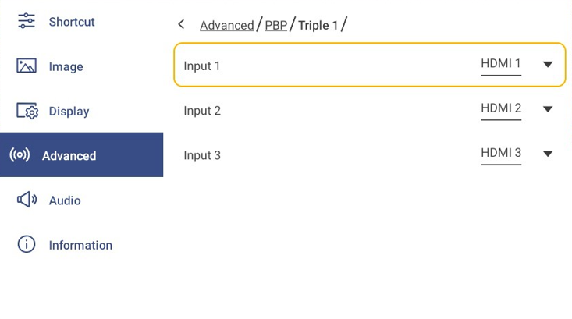

Select Input source for current selected layout of Quad Mode:

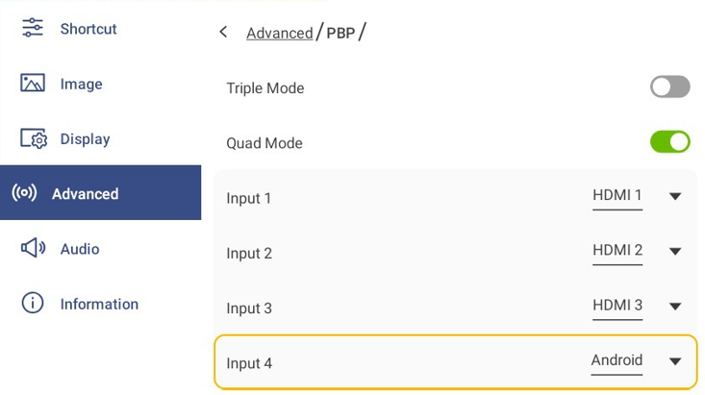

Multiple Output
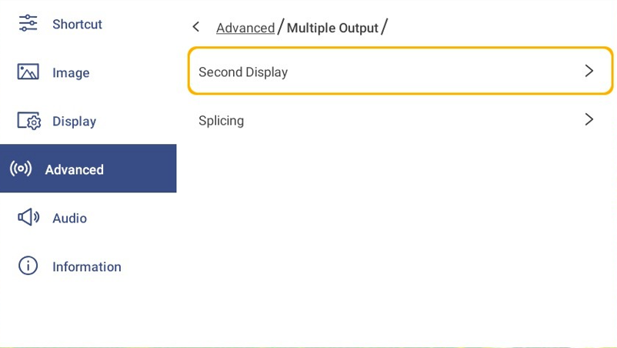
Second Display: the selected output source will output to HDMI 2 output
Click to enable Second display and select output source.

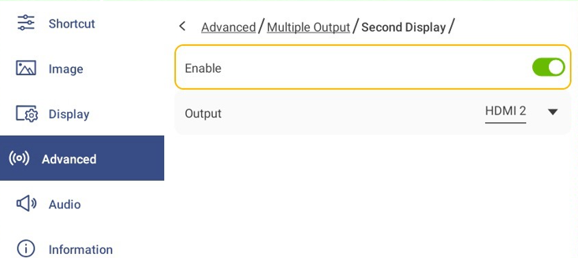

Splicing Mode – synchronization of multiple outputs

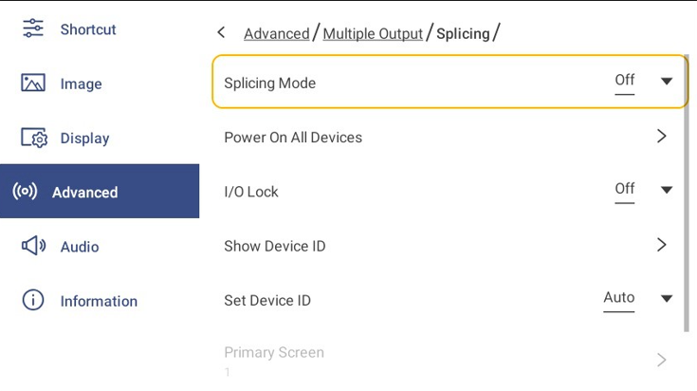

Menu item | Description | Options | Default
Splicing Mode | Enable 2x1 splicing screen | Off  2x1 | Off
Power On all devices | Turn on all device which connect together
Select I/O lock to synchronize outputs
I/O Lock | Input and output synchronization. | Off  Source Lock  Genlock | Off

Note:
1.Source Lock: output reference input
2.Genlock: the output refresh rate will follow the vertical sync of the signal connected to the Genlock BNC connector. Genlock is achieved when the Genlock vertical sync rate matches the vertical sync rate set in the output menu.

Set show Device ID to check ID of the device

Set Device ID
Set Device ID | Setting device ID | Auto  Manual | Auto
Primary Screen | Set Primary Device ID | 01-99 | 1
Secondary Screen | Set Secondary Device ID | 01-99 | 2

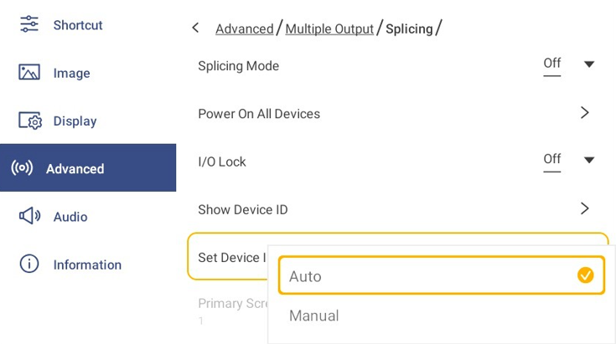

Note: PIP, PBP, Second Display, Splicing Mode, and Test Pattern conflict with each other. Turning on one mode will automatically turn off other modes.

Configuring Audio Settings
In the OSD menu, press  to open the Audio menu, then complete the following steps:

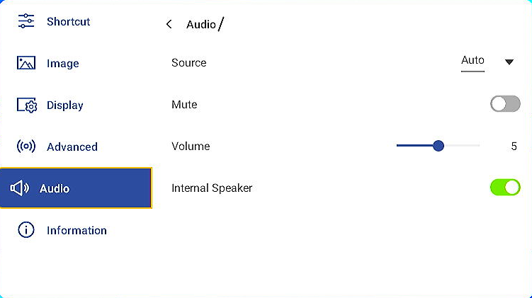

Press Mute to mute or unmute audio.

Drag the Volume slider bar to adjust the volume level.

Menu item | Description | Options | Default
Source | Select to audio source come from the select input.  Select auto will output the audio come from main input | Auto  HDMI 1  HDMI 2  HDMI 3  DP  3G-SDI  OPS | Auto
Mute | -Mute/Unmute all audio (Speaker and 3.5 mm jack) | Off  On | Off
Volume | -Adjust volume level | 0-10 | 5
Internal Speaker | Enable speaker audio | Off  On | On
Note: if audio source conflicts with other selected video sources, will have no sound output.

Viewing Device Information
In the OSD menu, select  to open the Information menu, then complete the following steps:

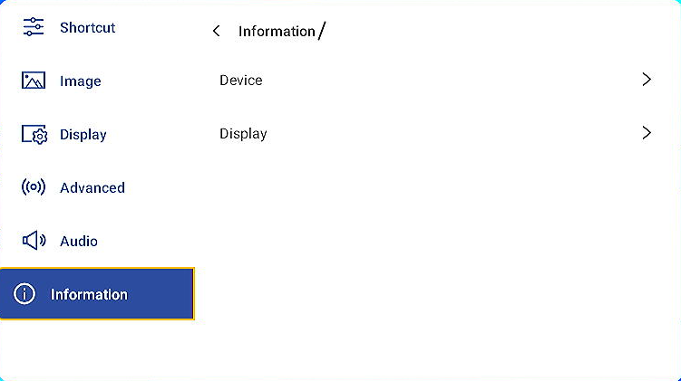
Select Device to view Ethernet IP address, Wi-Fi IP address, Device ID, S/N, LED Display Hours, AC In Voltage, Power mode (Standby), Android Version, FW System, FW sender, FW LED module.
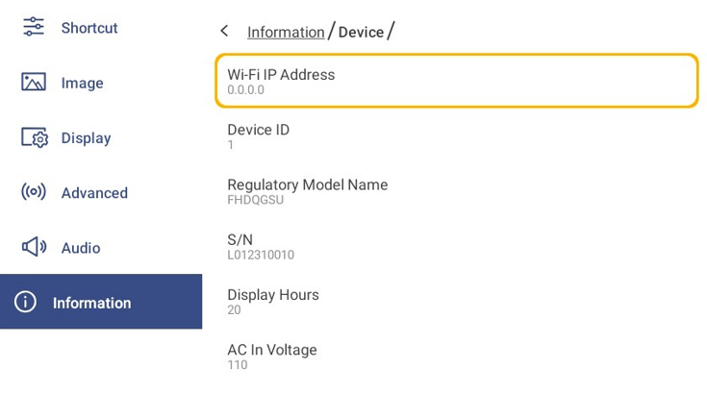
Select Display to view Input Source, Resolution, Refresh Rate, Display Mode, Color Depth, Color Format.
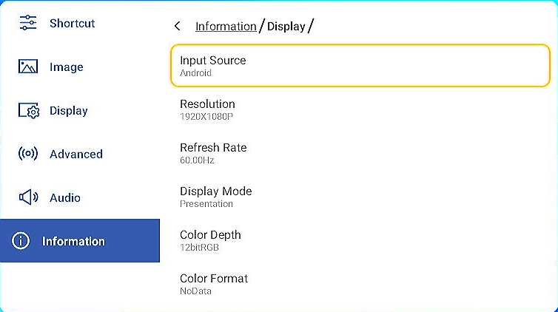

Android Settings Menu
To open the Settings menu, select on the Home screen.
Note: Settings can be modified only in Android mode.

Main menu Submenu Settings
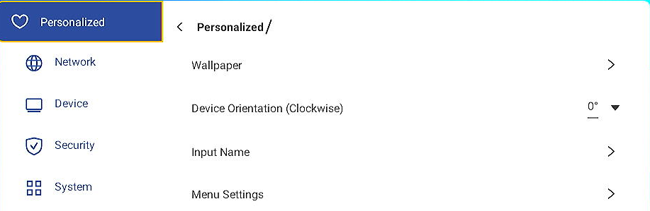

Note:
  - To configure Android settings, simply press the menu item on the screen and use the screen controls to adjust its value or set the setting. The selected menu item is highlighted in Blue.
  - To move to the previous item in the menu, press or press Back on the remote control.
  - To close the OSD menu press Back continuously (if necessary) on the remote control.

Personalizing the System
In the Settings menu, select  to open the Personalized menu, then complete the following steps:

- Press Wallpaper and select a pre-loaded image as a wallpaper or an image from your gallery

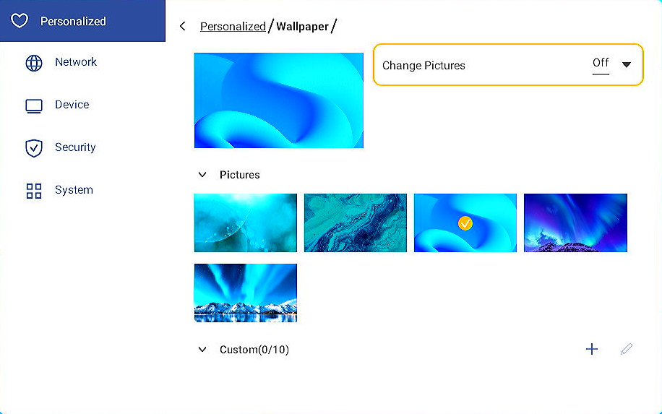

If you select a pre-loaded wallpaper from the Pictures folder, the setting will take effect immediately.
If you prefer to use a customized wallpaper, follow the steps:
- In the Custom folder press .
- Select your preferred image from the local or external storage and tap Import. You can import up to 10 images.
- In the Custom folder tap on the image you wish to use as a wallpaper. The setting takes effect immediately.
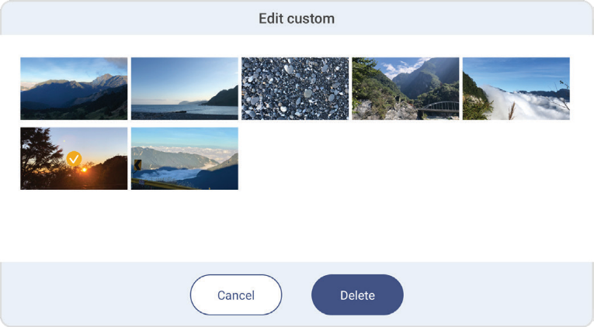
Note: To delete images in the Custom folder, select . Then select the image and press Delete.

- Type: Select the image type.
- Change pictures: Select the slideshow interval from 5mins to 1 day. By default, the slideshow is off.

- Select Input Name to rename the input. Press the input name you wish to change, then type a new name and
confirm name modification by selecting OK at the prompt.

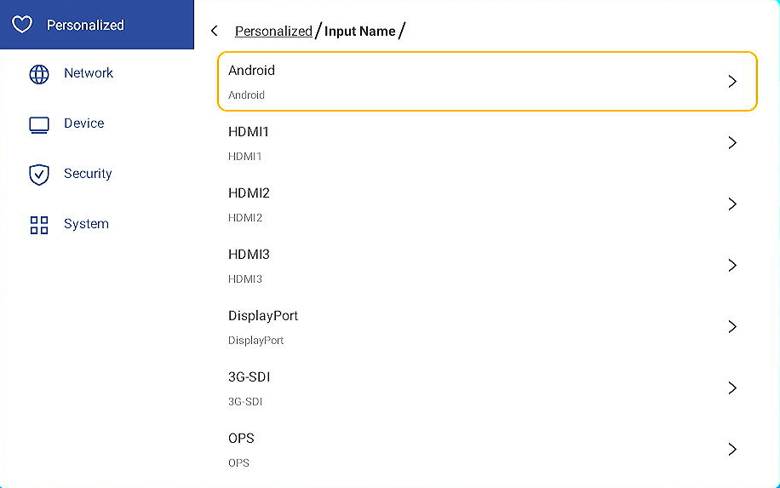

- Select Menu Settings to set the location and set close timer of menu.

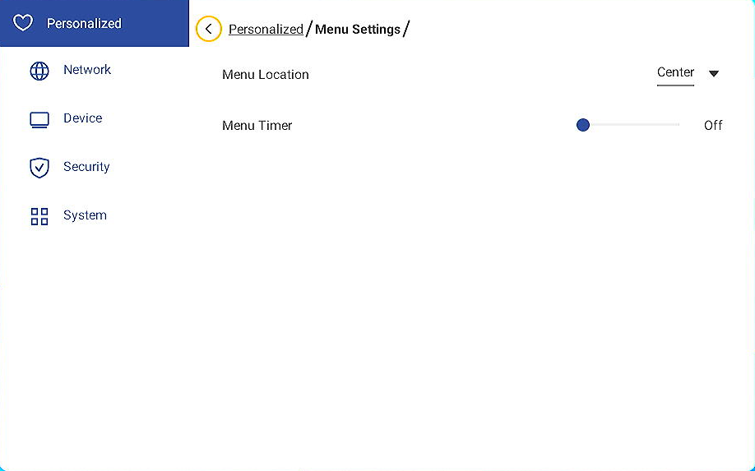

Menu item | Description | Options | Default
Menu location | Set location for the menu shown on screen | - Top Left  - Top Right  - Center  - Bottom Left  - Bottom Right | Center
Menu timer | Set duration for menu shown on the screen | Off to 60sec | 10 sec

Configuring Network Settings
In the Settings menu, select  to open the Network menu, then complete the following steps:
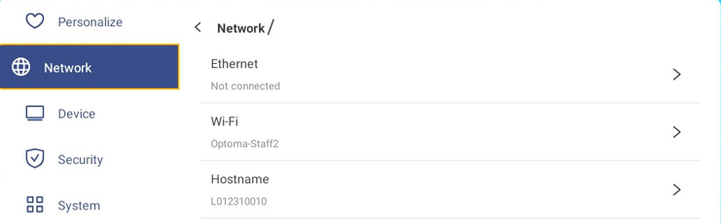

- Select Ethernet to configure LAN settings and view the current connection status. In the IP settings section select the network type between Static and DHCP. If you set the network type as Static then press and enter the connection settings, such as IP address, gateway, network prefix length, and more.
IMPORTANT! To connect to a wired network, make sure the device is connected to LAN. For more information, refer to page 12.

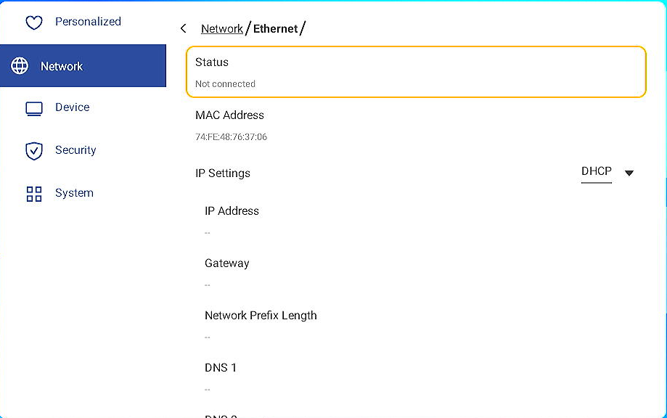
- Select Wi-Fi to connect the device to the Wi-Fi network and view current connection status. Make sure the
Wi-Fi function is enabled. In the Available network list, select your preferred Wi-Fi network, for example XXXX. Provide an access password if needed.
IMPORTANT! To connect to a Wi-Fi network, make sure the Wi-Fi dongle is properly installed in the Wi-Fi dongle slot. For more information, refer to page 12.
Note: If your preferred Wi-Fi network is not visible in the list, press  to refresh the list. To enter the Wi-Fi network manually, press .
- Enable Portable hotspot feature to share the Wi-Fi network to other wireless devices. Modify the network name and set an access password if necessary.
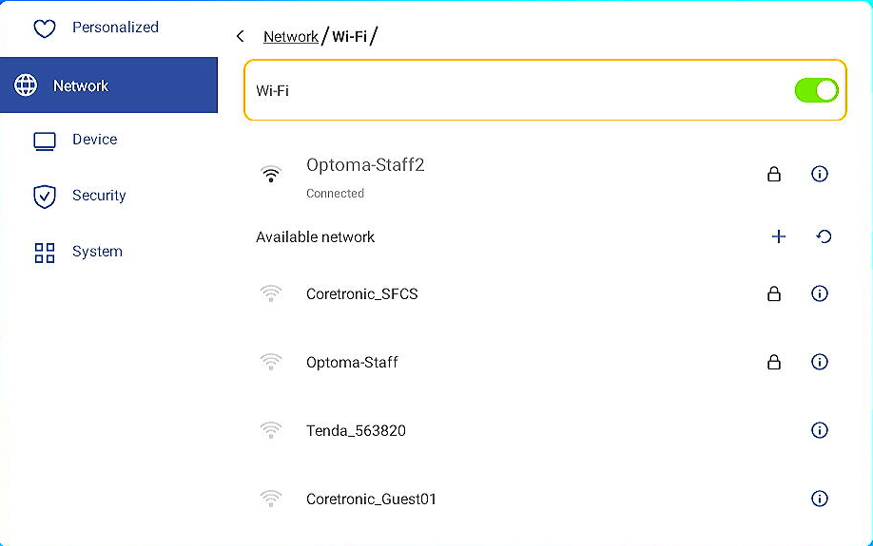
Note: For a secure connection, set the Wi-Fi encryption (Security field) as WPA2-PSK. Then enter the access password and press OK.

- Select Hostname to set up host name

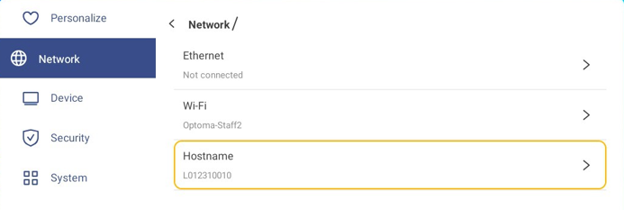

Configuring Device Settings
In the Settings menu, select  to open the Device menu, then complete the following steps:

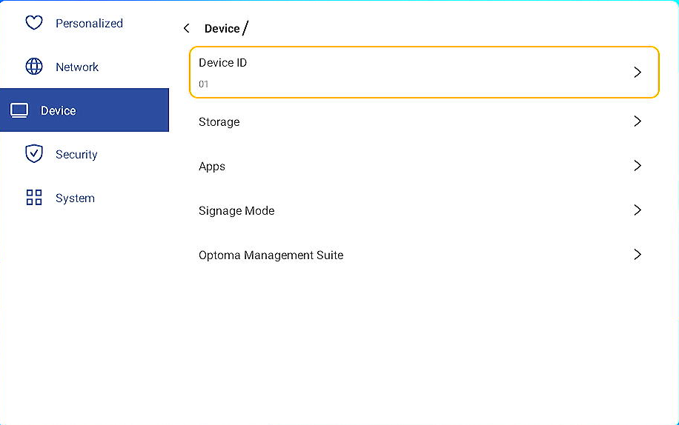

- Select Device ID to assign a new ID to the device. To confirm, select OK.

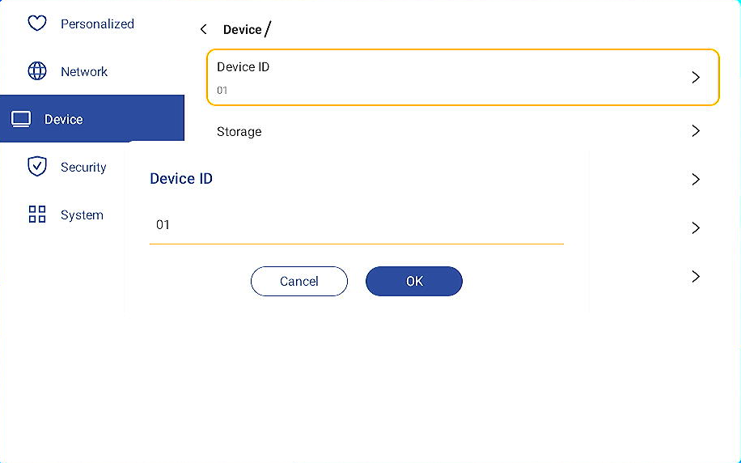

- Select Storage to view storage usage
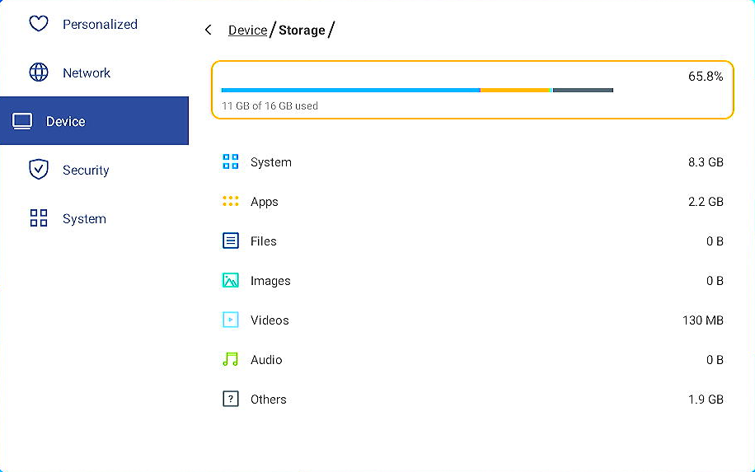

- Select Apps to view apps information, clear apps data and cache, and force stop apps.

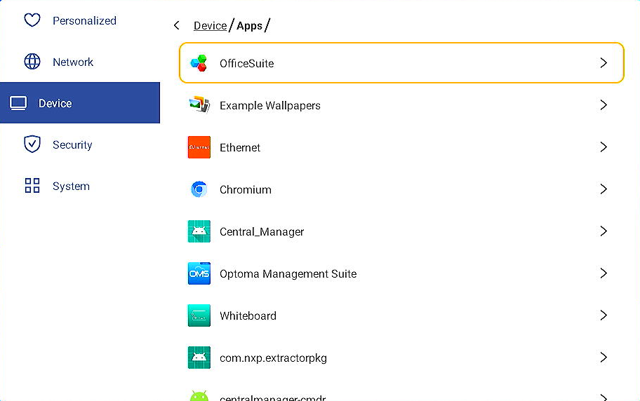

- Select an app in the list to force stop it (select Force stop), view its storage and clear its data (select Clear data) and Cache (press Clear cache), view app version and set permissions.

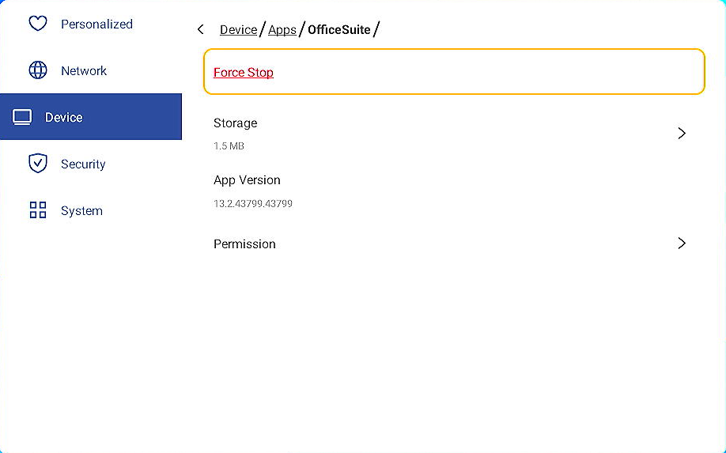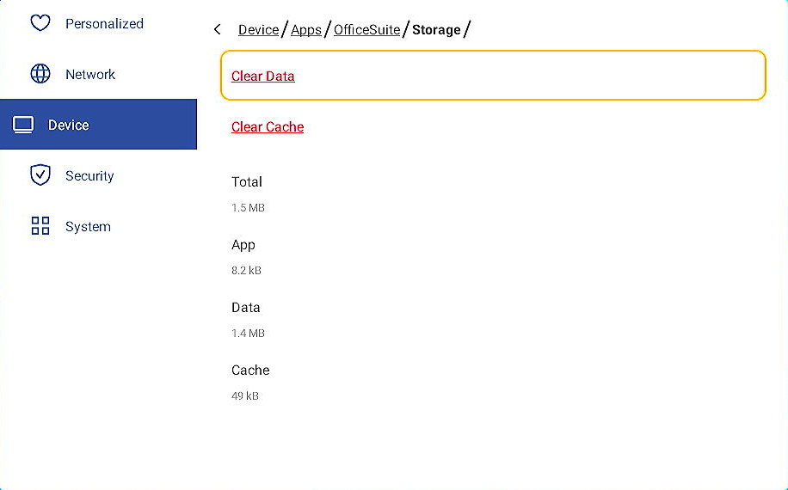

Configuring Security Settings
In the Settings menu, press  to open the Security menu, then complete the following steps:

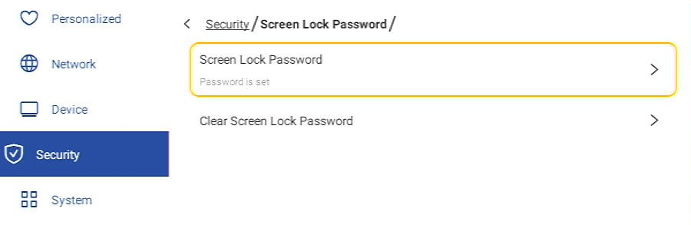

- Select Screen Lock Password to set screen lock password. Enter a 4-digit password twice at the prompt and then press OK to confirm.
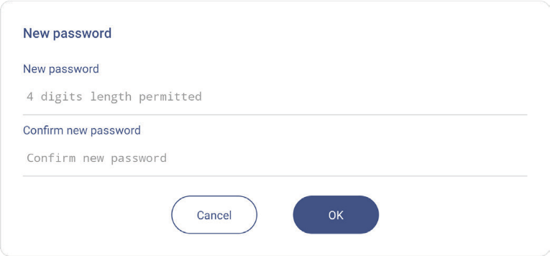
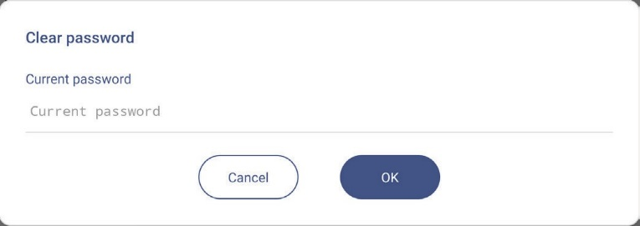
Note: To remove the screen lock password, press Clear Screen Lock Password (visible only if the password is set) and enter the current password. Then press OK to confirm.

Configuring System Settings
In the Settings menu, press  to open the System menu, then complete the following steps:
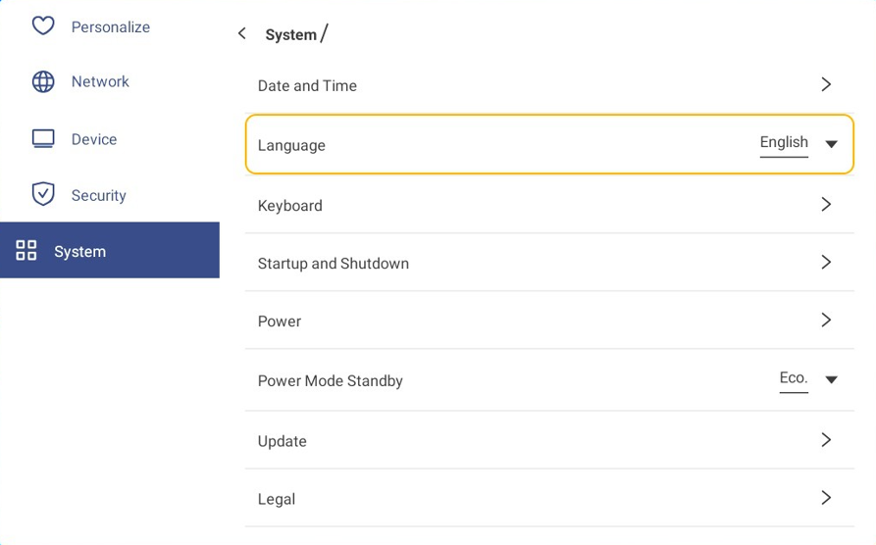

- Select Date and Time to configure date and time related settings. Choice any of the following:
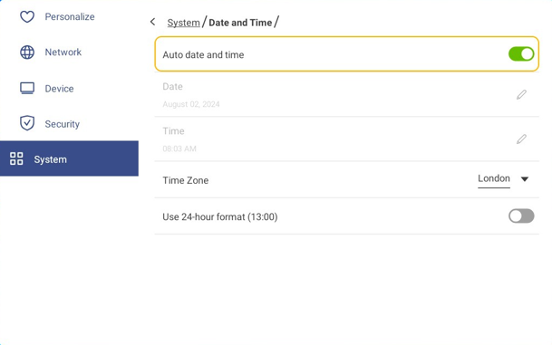

- Auto Date and Time to automatically set the time from your UTC.
- Time Zone to select/change the time zone for your area.
- Use 24-hour format (13:00) to enable or disable displaying time in 24-hour format.

- Press Language to select one of the available language options: English, French, Spanish, Traditional Chinese, Simplified Chinese, Portuguese, German, Dutch, Polish, Russian, Czech, Danish, Swedish, Italian, Turkish, Arabic, Romanian, Hungarian, Finnish, or Norwegian.

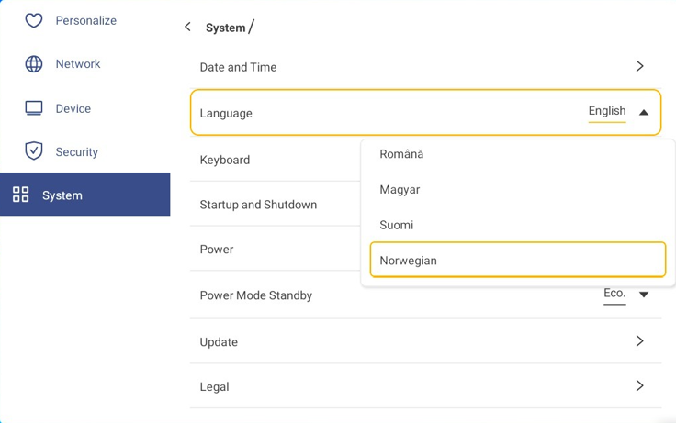
- Select Keyboard to view and manage keyboards.

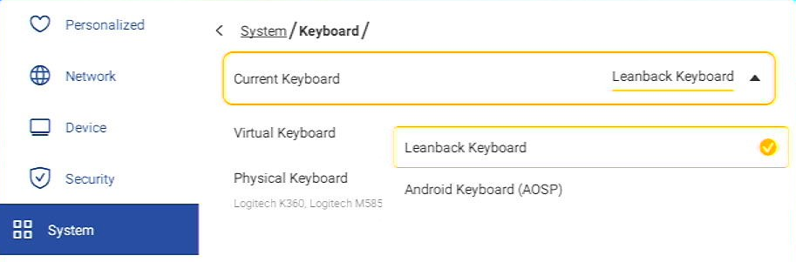

Menu item | Description | Options | Default
Current Keyboard |  | - Lean back keyboard  - keyboard (AOSP) | Lean back keyboard
Virtual Keyboard |  | - Android keyboard (AOSP)  - Lean back keyboard  Key board setting  (use system language to choose your input method)
Physical Keyboard |  |  | Default

- Select Startup and Shutdown to configure settings related to starting and shutting down the device. Select any of the following:

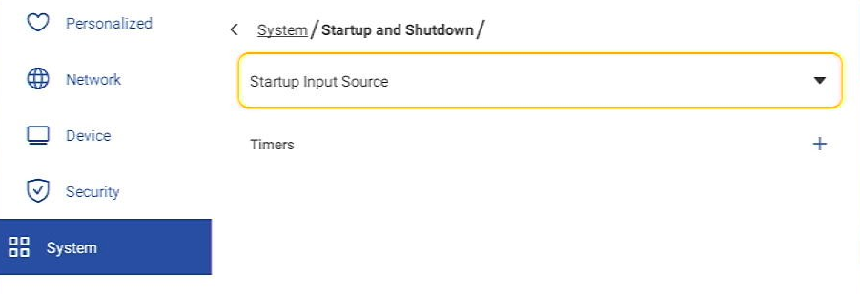

- Startup Input Source item to select one of the available startup input options: (Last Shutdown Input/Android/HDMI1/HDMI2/HDMI3/DP/3G-SDI/OPS).
- Timers ⇒  to set a startup and shutdown timer. To create a schedule, do the following:
  - To enable startup timer and/or shutdown timer, select the option button next to Startup timer and

Shutdown timer.

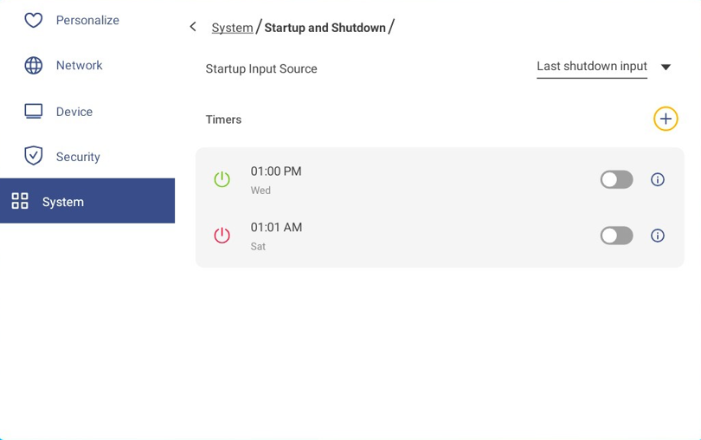
  - Set the time and select the day(s) when you want the device to follow this startup or shutdown schedule.
  - Press Add to save the timer. 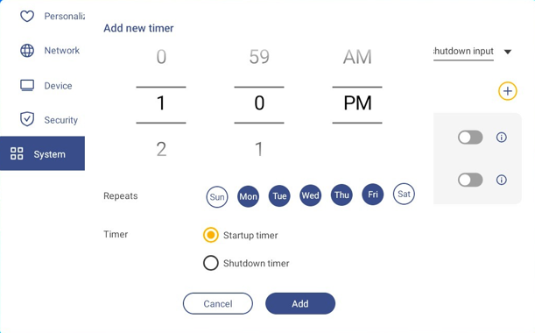

  - Enable (or disable) the new schedule in Timers menu.

Note:
    - Press  to modify or remove the schedule.
    - You can set up to 3 schedules.
- Select Power to configure power settings. Press any of the following:
- 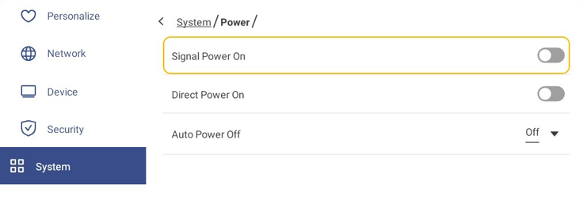

- Signal Power On to enable or disable starting up the device when an input signal is detected.
- Direct Power On to enable or disable starting up the device from the power source.
Note: Direct power on feature aids installations that rely on power-on timers.
- Auto Power Off Select one of the available time intervals to automatically power off the device when there’s no input source found. Off (function disabled), 1, 3, 5, 10, 15, 20, 25, 30, 35, 40, 45, 50, 55 or 60 (minutes).

- Select Power Mode Standby item to select one of the available options: Eco or Active.

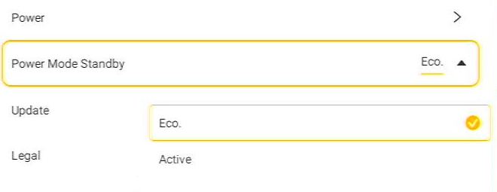

Note:
  - OMS and LAN control remote power on functions will only work when Power Mode (Standby) is set to

Active.
  - Power Mode Standby Active, consumes higher power as the system only turns off the display. The mainboard is still active and is listening for power on commands from LAN or OMS. If a remote power on requirement is not needed, we suggest that the Power Mode Standby is set to ECO.
  - It is recommended that during long periods of inactivity that the device is set to Power Mode Standby ECO and to turn off the LED for a period of time. This will help the system to release built up system resources.

- Select Update to configure upgrading options. Press any of the following
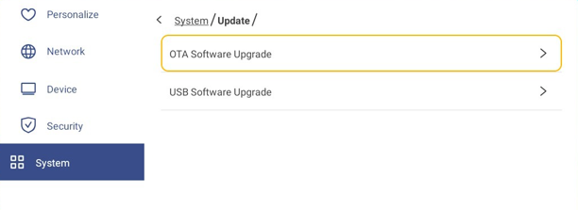
- OTA (Over-The-Air) Software Upgrade to enable or disable upgrading software over Internet. Press Auto to enable the system to check for firmware upgrades automatically every time the device is powered on and connected to the Internet. If the Auto option is disabled, the system will not check for firmware
upgrades automatically.

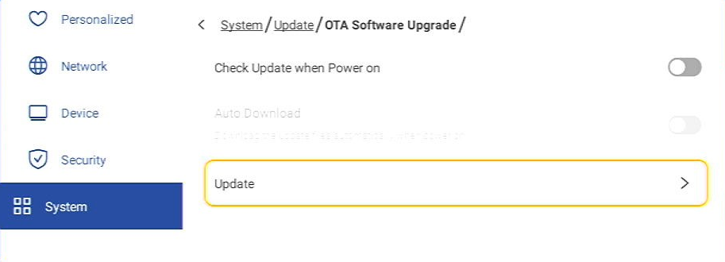
- To update the system manually, do the following:
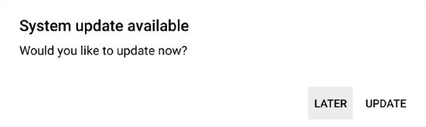
- Select UPDATE at the prompt.
- Select Download at the System Update window.

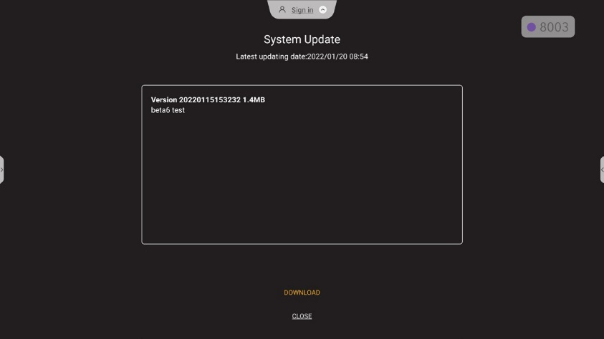

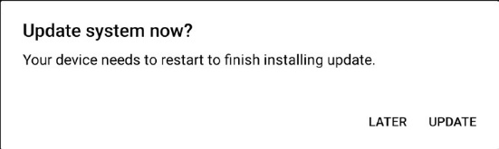
- Select UPDATE to start the update process.

Wait until the update process is complete.
Note: Upgrading software over the Internet requires network connection.
- USB Software Upgrade to update the system from a USB flash disk.]
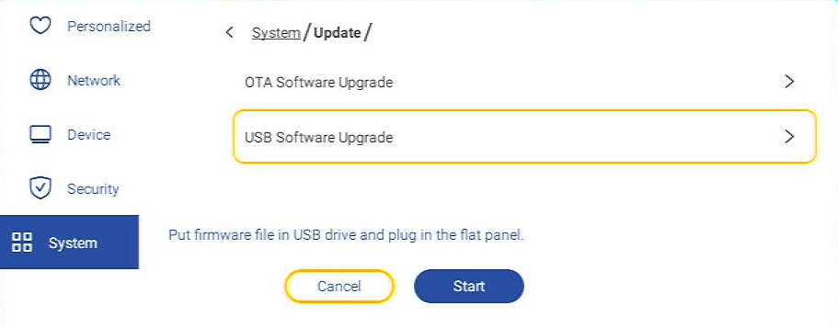
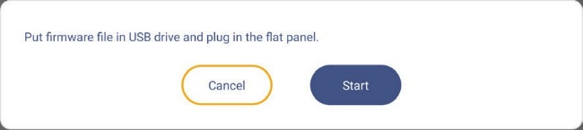
Note: To proceed with upgrading software, save the upgrade file to the USB flash disk first, then connect the disk to a USB 2.0 port on the Device. Open Advanced Settings ⇒ System ⇒ Update ⇒ USB Software Upgrade and tap Start at the prompt.

Note: When upgrading the device’s firmware from a USB storage, follow these steps:
Ensure that the USB flash disk is formatted to FAT32.
Firstly, extract the upgrade file.
Secondly, copy the extracted firmware file to the root directory of the USB flash disk.

IMPORTANT!
  - During the update process, either OTA (over the air) or from a USB storage, DO NOT power off the Device and DO NOT remove the USB dongle from the Device. Doing so will damage the system.

- Select Legal to view Terms and Conditions of Use, Privacy policy, Cookie policy, and Open Source Library

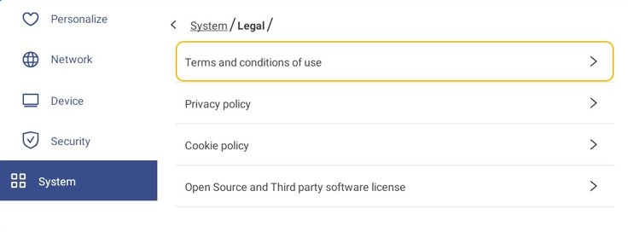

Optoma Management Suite (OMS)™ 

OMS is a large display management software that operates through LAN or over Internet. It simplifies the
management of the device remotely.
OMS has the following features:

- Accessible from anywhere with Internet access at any time.
- Device monitoring, alerts, control, scheduling, broadcasting, and more.
- Over-the-air firmware updates.
To start using OMS over LAN, complete the following steps:
- Connect the device and your PC to the same LAN.
Open the browser and download the OMS app to your PC from the Optoma web page:
Optoma Management Suite - OMS - Advanced remote management solution for audio visual displays (optomaeurope.com)
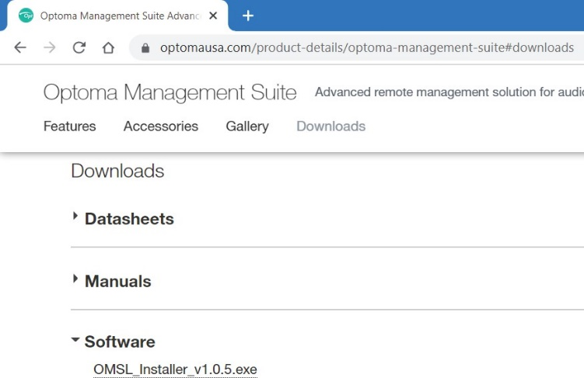
- Install OMS to your PC.
- Double-click on .
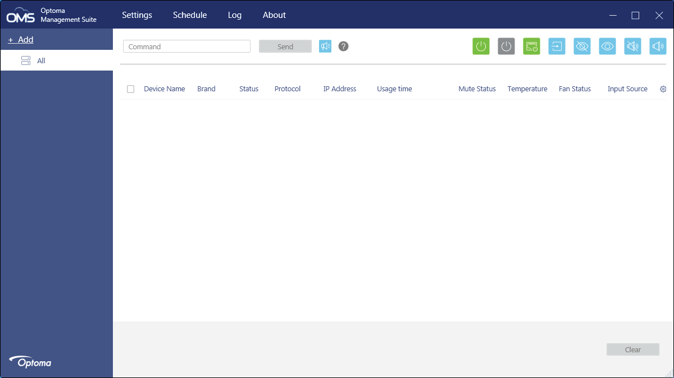
The OMS control page will open.

- Click on Add ⇒ Device.
- Select Automatic Search and click Search to search for devices automatically.
Note: If the device cannot be found automatically, then click Manual Search to search the device by the IP address or click Range Search to search the devices within the range of IP addresses.
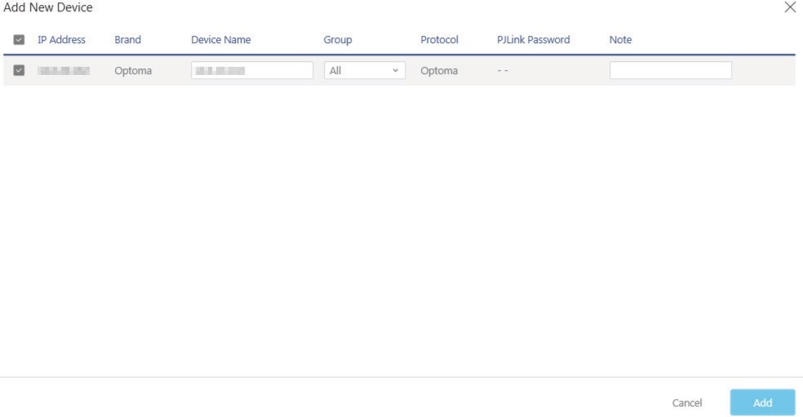
- Select the device and click Add.
- Select the device and then use the screen controls to display a message on the screen of the selected device, power on/off the device, enable/disable wake on LAN, select an input source, enable/disable AV mute mode, mute or unmute the device, monitor the device’s status, usage time, mute status, temperature, and more.
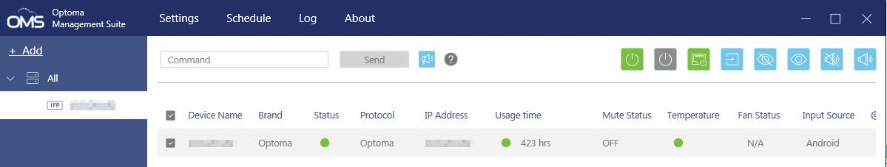
Note: For enhanced device management, you can group similar devices. To create a device group, click
Add ⇒ Group. Then add the selected devices to the group.

Additional Information

Supported Timing List
Format | Resolution | Frame  Rate(Hz) | SDI | HMDI 1  (2.0) | HMDI 2  (2.0) | HMDI 3  (2.0) | OPS  (2.0) | DP  (1.2)
SVGA | VESA  800 x 600 | 50 | X | V | V | V | V | V
SVGA | VESA  800 x 600 | 59.94 | X | V | V | V | V | V
SVGA | VESA  800 x 600 | 60 | X | V | V | V | V | V
XGA | VESA  1024 x 768 | 50 | X | V | V | V | V | V
XGA | VESA  1024 x 768 | 59.94 | X | V | V | V | V | V
XGA | VESA  1024 x 768 | 60 | X | V | V | V | V | V
720p | 1280 x 720 | 30 | V | V | V | V | V | V
720p | 1280 x 720 | 50 | V | V | V | V | V | V
720p | 1280 x 720 | 59.94 | V | V | V | V | V | V
720p | 1280 x 720 | 60 | V | V | V | V | V | V
WXGA | VESA  1280 x 800 | 50 | X | V | V | V | V | V
WXGA | VESA  1280 x 800 | 59.94 | X | V | V | V | V | V
WXGA | VESA  1280 x 800 | 60 | X | V | V | V | V | V
SXGA | VESA  1280 x 1024 | 50 | X | V | V | V | V | V
SXGA | VESA  1280 x 1024 | 59.94 | X | V | V | V | V | V
SXGA | VESA  1280 x 1024 | 60 | X | V | V | V | V | V
FWXGA | VESA  1366 x 768 | 50 | X | V | V | V | V | V
FWXGA | VESA  1366 x 768 | 59.94 | X | V | V | V | V | V
FWXGA | VESA  1366 x 768 | 60 | X | V | V | V | V | V
SXGA+ | VESA  1400 x 1050 | 50 | X | V | V | V | V | V
SXGA+ | VESA  1400 x 1050 | 59.94 | X | V | V | V | V | V
SXGA+ | VESA  1400 x 1050 | 60 | X | V | V | V | V | V
WXGA+ | VESA  1440 x 900 | 50 | X | V | V | V | V | V
WXGA+ | VESA  1440 x 900 | 59.94 | X | V | V | V | V | V
WXGA+ | VESA  1440 x 900 | 60 | X | V | V | V | V | V
UXGA | VESA  1600 x 1200 | 50 | X | V | V | V | V | V
UXGA | VESA  1600 x 1200 | 59.94 | X | V | V | V | V | V
UXGA | VESA  1600 x 1200 | 60 | X | V | V | V | V | V
1080i | 1920 x 1080 | 50 | V | V | V | V | V | V
1080i | 1920 x 1080 | 59.94 | V | V | V | V | V | V
1080i | 1920 x 1080 | 60 | V | V | V | V | V | V
1080p | 1920 x 1080 | 25 | V | V | V | V | V | V
1080p | 1920 x 1080 | 30 | V | V | V | V | V | V
1080p | 1920 x 1080 | 50 | V | V | V | V | V | V
1080p | 1920 x 1080 | 59.94 | V | V | V | V | V | V
1080p | 1920 x 1080 | 60 | V | V | V | V | V | V
UWFHD | 2560x1080 | 50 | X | V | V | V | V | V
UWFHD | 2560x1080 | 59.94 | X | V | V | V | V | V
UWFHD | 2560x1080 | 60 | X | V | V | V | V | V
WQHD | 2560x1440 | 50 | X | V | V | V | V | V
WQHD | 2560x1440 | 59.94 | X | V | V | V | V | V
WQHD | 2560x1440 | 60 | X | V | V | V | V | V
WQXGA | 2560x1600 | 50 | X | V | V | V | V | V
WQXGA | 2560x1600 | 59.94 | X | V | V | V | V | V
WQXGA | 2560x1600 | 60 | X | V | V | V | V | V
4K UHD | 3840x2160 | 30 | X | V | V | V | V | V
4K UHD | 3840x2160 | 50 | X | V | V | V | V | V
4K UHD | 3840x2160 | 59.94 | X | V | V | V | V | V
4K UHD | 3840x2160 | 60 | X | V | V | V | V | V

RS232 Protocol Function List
Note: DEVICE supports RS232 and RJ45 control command.

RS232 Pin Assignments
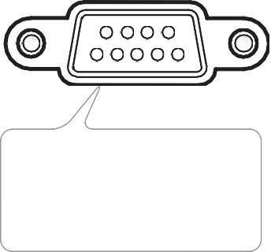









9 8 7 6

5 4 3 2 1
PIN No. | Spec  (from display side)
1 | N/A
2 | TXD
3 | RXD
4 | N/A
5 | GND
6 | N/A
7 | N/A
8 | N/A

RS232 RJ45 Control Connection

RS232 Settings |  |  | LAN Control Settings
Baud Rate | 9600 |  | IP | Machine IP
Data Bits | 8 |  | Port | 23
Parity | None
Stop Bits | 1
Flow Control | None
~
X
X
X
X
X
X
X
CR
Lead Code
Device ID
(where 01 indicates Device ID = 01)
Command ID
Space Variable Carriage return

SET Command

Type | Category | Parameter | CMD |  | Hex Code CMD | Response
 |  |  |  |  |  | Success | Failed
SET | Power | Power off | ~xx00 n | n=0 | 7E 30 30 30 30 20 30 0D | P | F
SET | Power | Power on | ~xx00 n | n=1 | 7E 30 30 30 30 20 31 0D | P | F
SET | Power | Restart | ~xx00 n | n=3 | 7E 30 30 30 30 20 33 0D | P | F
SET | Power Mode (standby) | Eco. | ~xx114 n | n=0 | 7E 30 30 31 31 34 20 30 0D | P | F
SET | Power Mode (standby) | Active |  | n=1 | 7E 30 30 31 31 34 20 31 0D | P | F
SET | Contrast | 0 ~ 100 | ~xx22 n | n=0-100 | 7E 30 30 32 32 20 30 0D  to  7E 30 30 32 32 20 31 30 30 0D | P | F
SET | Brightness | 0 ~ 100 | ~xx21 n | n=0-100 | 7E 30 30 32 31 20 30 0D  to  7E 30 30 32 31 20 31 30 30 0D | P | F
SET | Gamma | 1.8 | ~xx35 n | n=5 | 7E 30 30 33 35 20 35 0D | P | F
SET | Gamma | 2.0 | ~xx35 n | n=6 | 7E 30 30 33 35 20 36 0D | P | F
SET | Gamma | 2.2 | ~xx35 n | n=7 | 7E 30 30 33 35 20 37 0D | P | F
SET | Gamma | 2.4 | ~xx35 n | n=12 | 7E 30 30 33 35 20 31 32 0D | P | F
SET | Image Reset |  | ~xx509 n | n=1 | 7E 30 30 35 30 39 20 31 0D | P | F
SET | Volume | 0 ~ 10 | ~xx81 n | n=0-10 | 7E 30 30 38 31 20 30 0D  to  7E 30 30 38 31 20 31 30 30 0D | P | F
SET | Mute | Off | ~xx80 n | n=0 | 7E 30 30 38 30 20 30 0D | P | F
SET | Mute | On | ~xx80 n | n=1 | 7E 30 30 38 30 20 31 0D | P | F
SET | Input Source | HDMI1 | ~xx12 n | n=1 | 7E 30 30 31 32 20 31 0D | P | F
SET | Input Source | HDMI2 | ~xx12 n | n=15 | 7E 30 30 31 32 20 31 35 0D | P | F
SET | Input Source | HDMI3 | ~xx12 n | n=16 | 7E 30 30 31 32 20 31 36 0D | P | F
SET | Input Source | DP | ~xx12 n | n=20 | 7E 30 30 31 32 20 32 30 0D | P | F
SET | Input Source | 3G-SDI | ~xx12 n | n=22 | 7E 30 30 31 32 20 32 32 0D | P | F
SET | Input Source | OPS | ~xx12 n | n=25 | 7E 30 30 31 32 20 32 35 0D | P | F
SET | Input Source | Android | ~xx12 n | n=24 | 7E 30 30 31 32 20 32 34 0D | P | F
SET | Aspect Ratio | 4:3 | ~xx60 n | n=1 | 7E 30 30 36 30 20 31 0D | P | F
SET | Aspect Ratio | 16:9 | ~xx60 n | n=2 | 7E 30 30 36 30 20 32 0D | P | F
SET | Aspect Ratio | Auto | ~xx60 n | n=7 | 7E 30 30 36 30 20 37 0D | P | F
SET | Language | English | ~xx70 n | n=1 | 7E 30 30 37 30 20 31 0D | P | F
SET | Language | Français | ~xx70 n | n=3 | 7E 30 30 37 30 20 33 0D | P | F

Type | Category | Parameter | CMD |  | Hex Code CMD | Response
 |  |  |  |  |  | Success | Failed
SET | Language | Español | ~xx70 n | n=5 | 7E 30 30 37 30 20 35 0D | P | F
SET | Language | Traditional Chinese | ~xx70 n | n=13 | 7E 30 30 37 30 20 31 33 0D | P | F
SET | Language | Simplified  Chinese | ~xx70 n | n=14 | 7E 30 30 37 30 20 31 34 0D | P | F
SET | Language | Português | ~xx70 n | n=6 | 7E 30 30 37 30 20 36 0D | P | F
SET | Language | German | ~xx70 n | n=2 | 7E 30 30 37 30 20 32 0D | P | F
SET | Language | Dutch | ~xx70 n | n=8 | 7E 30 30 37 30 20 38 0D | P | F
SET | Language | Polish | ~xx70 n | n=7 | 7E 30 30 37 30 20 37 0D | P | F
SET | Language | Russia | ~xx70 n | n=17 | 7E 30 30 37 30 20 31 37 0D | P | F
SET | Language | Czech | ~xx70 n | n=19 | 7E 30 30 37 30 20 31 39 0D | P | F
SET | Language | Danish | ~xx70 n | n=24 | 7E 30 30 37 30 20 32 34 0D | P | F
SET | Language | Swedish | ~xx70 n | n=9 | 7E 30 30 37 30 20 39 0D | P | F
SET | Language | Italian | ~xx70 n | n=4 | 7E 30 30 37 30 20 34 0D | P | F
SET | Language | Turkish | ~xx70 n | n=22 | 7E 30 30 37 30 20 32 32 0D | P | F
SET | Language | Arabic | ~xx70 n | n=20 | 7E 30 30 37 30 20 32 30 0D | P | F
SET | Language | Romanian | ~xx70 n | n=27 | 7E 30 30 37 30 20 32 37 0D | P | F
SET | Language | Hungarian | ~xx70 n | n=18 | 7E 30 30 37 30 20 31 38 0D | P | F
SET | Language | Finnish | ~xx70 n | n=11 | 7E 30 30 37 30 20 31 31 0D | P | F
SET | Language | Norge | ~xx70 n | n=10 | 7E 30 30 37 30 20 31 30 0D | P | F
SET | Display Mode | Presentation | ~xx20 n | n=1 | 7E 30 30 32 30 20 31 0D | P | F
SET | Display Mode | Bright | ~xx20 n | n=2 | 7E 30 30 32 30 20 32 0D | P | F
SET | Display Mode | Cinema | ~xx20 n | n=3 | 7E 30 30 32 30 20 33 0D | P | F
SET | Display Mode | HDR | ~xx20 n | n=21 | 7E 30 30 32 30 20 32 31 0D | P | F
SET | Display Mode | User | ~xx20 n | n=5 | 7E 30 30 32 30 20 35 0D | P | F
SET | Color | 0 ~ 100 | ~xx45 n | n=0-100 | 7E 30 30 34 35 20 30 0D  to  7E 30 30 34 35 20 31 30 30 0D | P | F
SET | Color Temp | 9300K | ~xx36 n | n=2 | 7E 30 30 33 36 20 32 0D | P | F
SET | Color Temp | 6500K | ~xx36 n | n=1 | 7E 30 30 33 36 20 31 0D | P | F
SET | Color Temp | 3200K | ~xx36 n | n=4 | 7E 30 30 33 36 20 34 0D | P | F
 |  | 12000K |  | n=3 | 7E 30 30 33 36 20 33 0D | P | F
 | LLED LED Brightness | 1~100 | ~xx251 n | n=1-100 | 7E 30 30 32 35 31 20 31 0D  to  7E 30 30 32 35 31 20 31 30 30 0D | P | F

GET Command

Type | Category | CMD |  | Hex Code CMD | Response
 |  |  |  |  | Success | Parameter | Failed
GET | Power | ~xx124 n | n=1 | 7E 30 30 31 32 34 20  31 0D | Ok0 | Power off | F
 |  |  |  |  | OK1 | Power on | F
GET | Contrast | ~xx126 n | n=1 | 7E 30 30 31 32 36 20  31 0D | OK0-100 | 0-100 | F
GET | Brightness | ~xx125 n | n=1 | 7E 30 30 31 32 35 20  31 0D | OK0-100 | 0-100 | F
GET | Volume | ~xx120 n | n=1 | 7E 30 30 31 32 30 20  31 0D | OK0-10 | 0-10 | F
GET | Mute | ~xx356 n | n=1 | 7E 30 30 33 35 36 20  31 0D | OK0 | Off | F
 |  |  |  |  | OK1 | On | F
GET | Input Source | ~xx121 n | n=1 | 7E 30 30 31 32 31 20  31 0D | OK7 | HDMI1 | F
 |  |  |  |  | OK8 | HDMI2 | F
 |  |  |  |  | OK9 | HDMI3 | F
 |  |  |  |  | OK15 | DP | F
 |  |  |  |  | OK18 | 3G-SDI | F
 |  |  |  |  | OK21 | OPS | F
 |  |  |  |  | OK20 | Android | F

Type | Category | CMD |  | Hex Code CMD | Response
 |  |  |  |  | Success | Parameter | Failed
GET | Aspect Ratio | ~xx127 n | n=1 | 7E 30 30 31 32 37 20  31 0D | OK1 | 4:3 | F
 |  |  |  |  | OK2 | 16:9 | F
 |  |  |  |  | OK7 | Auto | F
GET | Display Mode | ~xx123 n | n=1 | 7E 30 30 31 32 33 20  31 0D | OK1 | Presentation | F
 |  |  |  |  | OK2 | Bright | F
 |  |  |  |  | OK3 | Cinema | F
 |  |  |  |  | OK21 | HDR | F
 |  |  |  |  | OK5 | User | F
GET | Color Temp | ~xx128 n | n=1 | 7E 30 30 31 32 38 20  31 0D | OK3 | 3200K | F
 |  |  |  |  | OK0 | 6500K | F
 |  |  |  |  | OK1 | 9300K | F
 |  |  |  |  | OK2 | 12000K | F
GET | WLAN IP  address | ~xx451 n | n=2 | 7E 30 30 34 35 31 20  32 0D | Oknnn:nnn:nnn:nnn | IP address | F
GET | LAN Mac address | ~xx555 n | n=1 | 7E 30 30 35 35 35 20  31 0D | Oknn:nn:nn:nn:nn:nn | Mac Address | F
GET | LAN IP  address | ~xx87 n | n=3 | 7E 30 30 38 37 20 33 0D | Oknnn:nnn:nnn:nnn | IP address | F
GET | FW version | ~xx122 n | n=1 | 7E 30 30 31 32 32 20  31 0D | Oknnnnnnnn | FW version | F
GET | MCU version | ~xx357 n | n=2 | 7E 30 30 33 35 37 20  32 0D | Oknnnnnnnn | Device type = DEVICE | F
GET | Information string | ~xx150 n | n=1 | 7E 30 30 31 35 30 20  31 0D | OKabbbbbccddddee (Note*1) |  | F
GET | Information string | ~xx150 n | n=2 | 7E 30 30 31 35 30 20  32 0D | Oknnn | Device native resolution | F
GET | Information string | ~xx150 n | n=3 | 7E 30 30 31 35 30 20  33 0D | Oknnn (ex. OKHDMI1) | Input source | F
GET | Information string | ~xx150 n | n=4 | 7E 30 30 31 35 30 20  34 0D | Oknnn  (ex. OK1920x1080) | Source resolution | F
GET | Information string | ~xx150 n | n=16 | 7E 30 30 31 35 30 20 31  36 0D | OK0 | Power mode (standby) = Eco. | F
 |  |  |  |  | OK1 | Power mode (standby) = Active | F
GET | Information string | ~xx150 n | n=18 | 7E 30 30 31 35 30 20 31  38 0D | Oknnn (ex. OK48) | System temperature | F
GET | Information string | ~xx150 n | n=19 | 7E 30 30 31 35 30 20 31  39 0D | Oknnn (ex. OK60Hz) | Source refresh rate | F

Type | Category | CMD |  | Hex Code CMD | Response
 |  |  |  |  | Success | Parameter | Failed
GET | Regulatory Model name | ~xx151 n | n=3 | 7E 30 30 31 35 31 20  33 0d | Oknnn (ex. SLUGRK) | FHDQGSUS | F
Note: (*1)

Power | Running Time | Input Source | Firmware Version | Display Mode
- a=0 Power Off | Usage hours = nnnnn | - cc=07 HDMI1 | # # # # | - ee=01 Presentation
- a=1 Power On |  | - cc=08 HDMI2 |  | - ee=02 Bright
 |  | - cc=09 HDMI3 |  | - ee=05 User
 |  | - cc=15 HDMI3 |  | - ee=03 Cinema
 |  | - cc=18 DP |  | - ee=21 HDR
 |  | - cc=21 3G-SDI
 |  | - cc=20 OPS
 |  | - cc=21 Android

LED Indicator

Power LED Color & Behavior | Status
Solid Red | Standby mode
Solid Green | Power on
Flash Red (2 seconds) | Shutting down
Flash Green | Booting up
Flash Red (1 second) | Sender connection error
Flash Green and Red | SmartBorad Error

Optoma Global Offices
For service or support, please contact your local office
USA |  | Japan
47697 Westinghouse Drive, | 888-289-6786 | 東京都足立区綾瀬3-25-18
Fremont, CA 94539, USA | 510-897-8601 |   株式会社オーエス | info@os-worldwide.com
  www.optomausa.com | services@optoma.com | コンタクトセンター:0120-380-495 | www.os-worldwide.com
Canada |  | Taiwan
47697 Westinghouse Drive, | 888-289-6786 | 12F., No.213, Sec. 3, Beixin Rd., | +886-2-8911-8600
Fremont, CA 94539, USA | 510-897-8601 | Xindian Dist., New Taipei City 231, | +886-2-8911-6550
www.optomausa.com | services@optoma.com | Taiwan, R.O.C. | services@optoma.com.tw
 |  | www.optoma.com.tw | asia.optoma.com
Latin America
47697 Westinghouse Drive, | 888-289-6786 | Hong Kong
Fremont, CA 94539, USA | 510-897-8601 | Unit A, 27/F Dragon Centre,
www.optomausa.com | services@optoma.com | 79 Wing Hong Street, | +852-2396-8968
 |  | Cheung Sha Wan, | +852-2370-1222
Europe |  | Kowloon, Hong Kong | www.optoma.com.hk
Unit 1, Network 41, Bourne End Mills,
Hemel Hempstead, Herts, |  | China
HP1 2UJ, United Kingdom | +44 (0) 1923 691 800 | Room 2001, 20F, Building 4, | +86-21-62947376
www.optoma.eu | +44 (0) 1923 691 888 | No. 1398 Kaixuan Road, | +86-21-62947375
Service Tel : +44 (0)1923 691865 | service@tsc-europe.com | Changning District | servicecn@optoma.com.cn
 |  | Shanghai, 200052, China | www.optoma.com.cn
Benelux BV
  Randstad 22-123 | +31 (0) 36 820 0252 | Korea
1316 BW Almere | +31 (0) 36 548 9052 | WOOMI TECH.CO.,LTD. | +82+2+34430004
The Netherlands |  | 4F, Minu Bldg.33-14, Kangnam-Ku, | +82+2+34430005
www.optoma.nl |  | Seoul,135-815, KOREA
 |  | korea.optoma.com
France
Bâtiment E | +33 1 41 46 12 20
81-83 avenue Edouard Vaillant | +33 1 41 46 94 35
92100 Boulogne Billancourt, France | savoptoma@optoma.fr
Spain
  C/ José Hierro,36 Of. 1C | +34 91 499 06 06
28522 Rivas VaciaMadrid, Spain | +34 91 670 08 32
Deutschland
Wiesenstrasse 21 W | +49 (0) 211 506 6670
D40549 Düsseldorf, | +49 (0) 211 506 66799
Germany | info@optoma.de
Scandinavia
Lerpeveien 25 | +47 32 98 89 90
3040 Drammen | +47 32 98 89 99
Norway | info@optoma.no
PO.BOX 9515
3038 Drammen
Norway

www.optoma.com

