
User manual

Installation Guide
BX-CTA28 Ultra Short Throw Lens

TABLE OF CONTENTS
Safety precautions 3
List of components 4
Required tools 4
Installing the UST lens 4
Boresight Adjustment 6
Operating the UST lens 10
Remove the UST lens 11

Ultra short throw (UST) lens installation
The ultra short throw (UST) lens enables large screen projection from a short distance, which significantly increases the flexibility of projector installation. This installation guide provides detailed steps on mounting the UST lens to your projector. Before the installation, please read through this guide in full to ensure the installation steps are made correctly.

Safety precautions
- Installation and adjustments should be performed by qualified Technicians or authorized service dealers.
- Ensure the projector is turned off and the lens rubber is removed before installing or removing the UST lens.
- Do not look into straight into the projector lens when the projector is operating. The bright light may cause permanent eye injury.
- Make sure no personnel or object is in the light path of the projector when it is running.
- Do not place the projector on an unstable surface to prevent product damage and personal injury.
- Failure to follow the control, adjustment or operation procedures may cause damage by the exposure of laser radiation.

Disclaimer
The information in this document is subject to change without notice. The manufacturer makes no representations or warranties with respect to the contents hereof and specifically disclaims any implied warranties of merchantability or fitness for any particular purpose. The manufacturer reserves the right to revise this publication and to make changes from time to time in the content hereof without obligation of the manufacturer to notify any person of such revision or changes

Trademarks
Optoma and its logo is a registered trademark of Optoma Corporation. Optoma Europe Ltd is the licensee of the registered trademark.

List of components
Check to make sure the following items are included in the UST lens package. Contact your dealer if anything is missing.
  - UST Lens
  - Supporting system components
Supporting system components | Quantity
U-shaped socket key | 1
Boresight hexagon bars | 4
L-shaped hex key | 1
S-shaped offset wrench | 1

Required tools
The following tools are required for installing the UST lens.
  - L-shaped hex key (provided inside the lens package)
  - S-shaped offset wrench (provided inside the lens package)

Installing the UST lens
- Please remove the lens rubber before installing or replacing the UST lens.
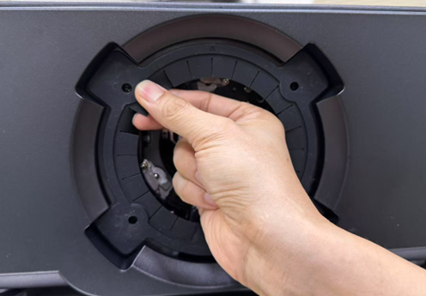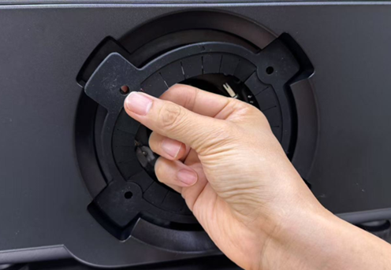
Note: To remove the rubber ring, please gently detach the rubber ring starting from the four corners in sequence. Do not pull on other parts of the rubber ring to avoid damage.

- Use an L-shaped hex wrench to loosen the two plate screws by turning counterclockwise.
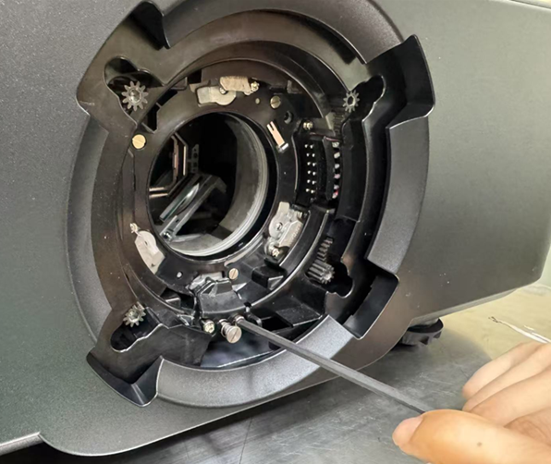
Note: If the screws continue to rotate after more than nine turns, this indicates they are fully loosened. Stop turning to prevent potential damage.
- Move the lens shift module to the topmost position.
- After turning on the projector, press the ‘LENS’ button on the projector keypad or any button in the ‘LENS SHIFT’ section on the remote control, and then press the ‘Up’ button until the Lens Shift Module reaches its highest position.
- If the projector lens has been removed, the light source remains off while the lens shift module is moving to its uppermost position; only the sound of the lens shift module motor will be audible.
- The lens shift module will automatically stop moving when it reaches the uppermost position.
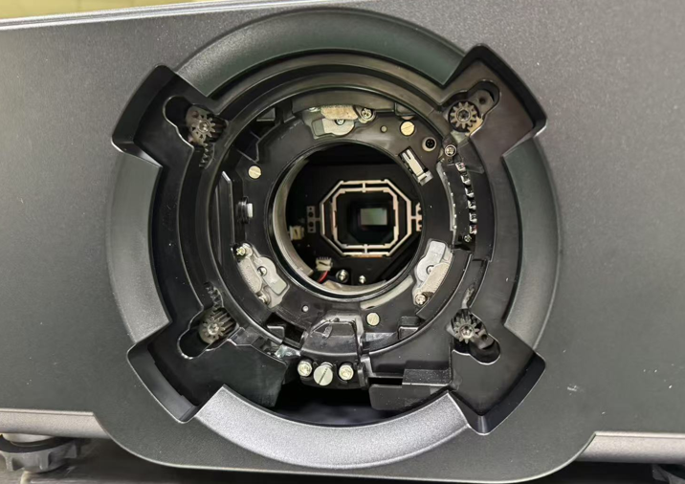

- Gently insert the UST lens at an angle of about 35 degrees, and then rotate it clockwise slowly until it is securely locked in place.
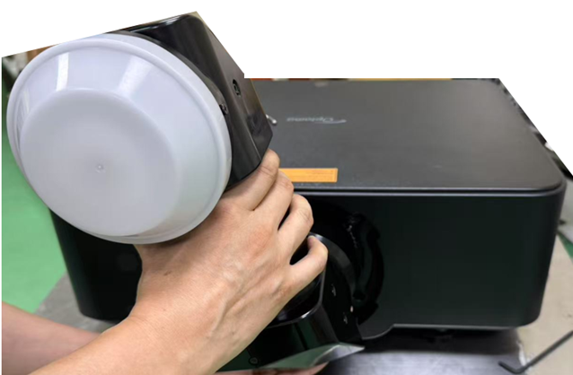
- Re-tighten the two plate screws by turning clockwise using an L-shaped hex wrench.
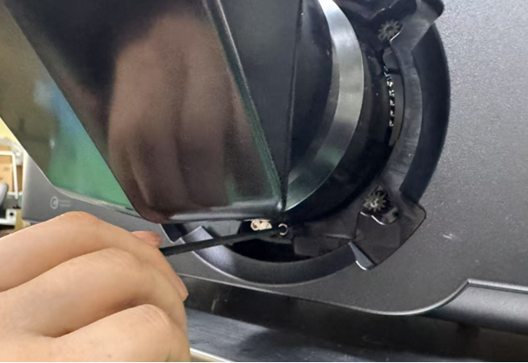

Boresight Adjustment
Only apply a boresight adjustment in case the overall focus of the projected image is not equally sharp. The boresight adjustment helps to balance the tilt of the lens mount to sharpen the unfocused sections of the image. It tilt the lens holder to parallel the lens plane and the DMD plane.
Note: This boresight adjustment process may cause the other areas of the image to slide out of focus. This is total normal.
Setting the Projector Start Mode
  - From the OSD menu, select Device Setup → Test Pattern → Full Screen.
  - Prepare the test area. Verify that the throw ratio of the installed lens matches the requirements of the installation area (projection distance and screen size).
  - Check that the lens is correctly installed.
Preforming the Boresight Adjustment
- Use the Allen key to adjust the four boresight screws.
Note: It can be used by general hexagon wrenches.
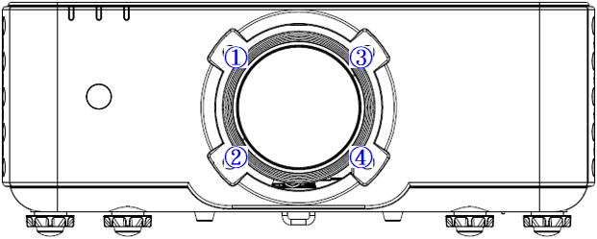
- Zoom the lens to its widest opening.
- Adjust the focus control to search for the best sharpness of the projected image.
- Adjusting the vertical image resolution.
  - Turn screws ① and ③ clockwise 1/8 turn and turn screws ② and ④ counterclockwise 1/8 turn. Then repeat until the image is clear on both the top and bottom of the screen.
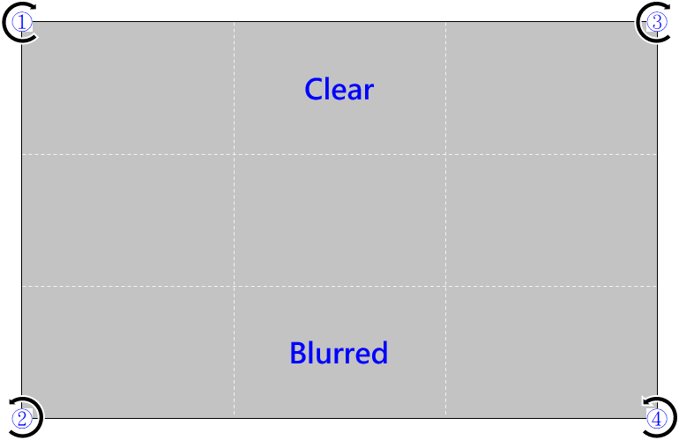
  - Turn screws ① and ③ counterclockwise 1/8 turn and turn screws ② and ④ clockwise 1/8 turn. Then repeat until the image is clear on both the top and bottom of the screen.
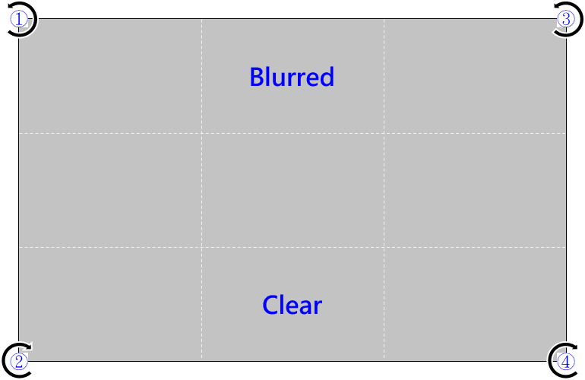
- Adjusting the center square image resolution.
  - Roughly adjust screws ①, ②, ③, and ④ clockwise by 1/8 turn.
  - Finely adjust screws ①, ②, ③, and ④ clockwise by 1/16 turn.
  - Then adjust until the entire screen is clear.
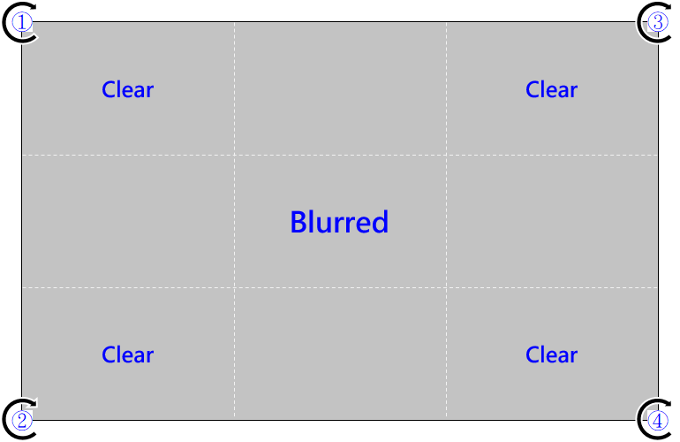
  - Roughly adjust screws ①, ②, ③, and ④ counterclockwise by 1/8 turn.
  - Finely adjust screws ①, ②, ③, and ④ counter clockwise by 1/16 turn.
  - Then adjust until the entire screen is clear.
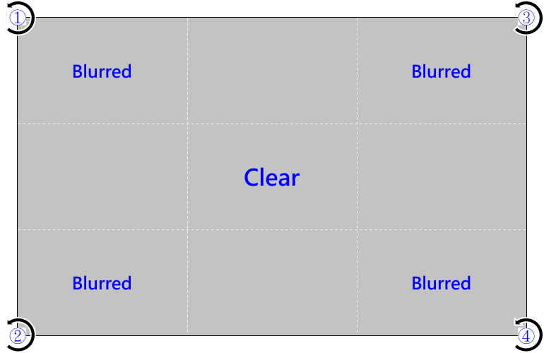
- Fine tuning the entire screen is clear.
Adjust the screw clockwise a 1/8 turn for the blurred area and 11/16 turn for the adjacent areas. Adjust until the entire screen is clear.
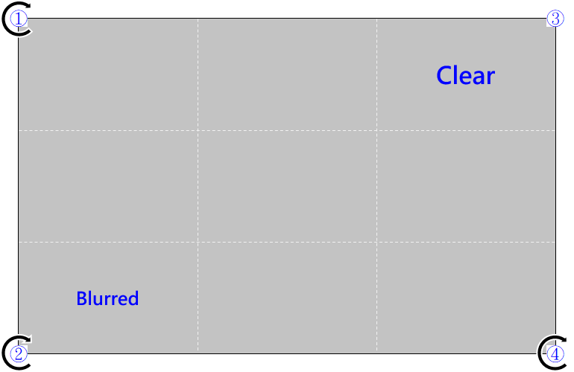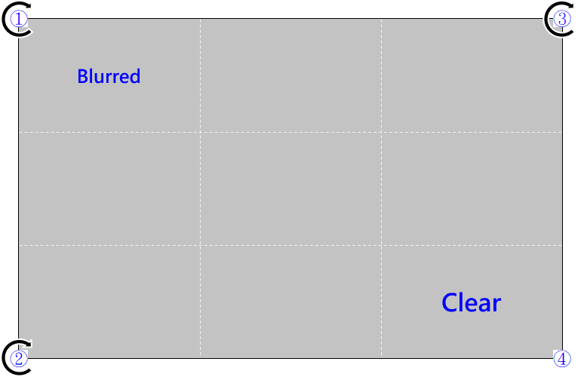
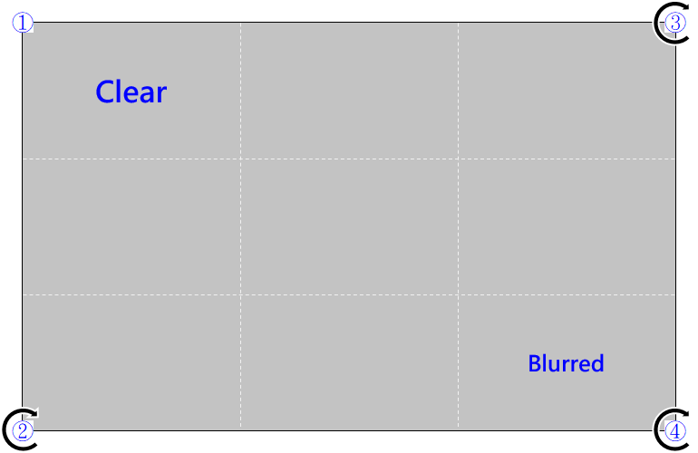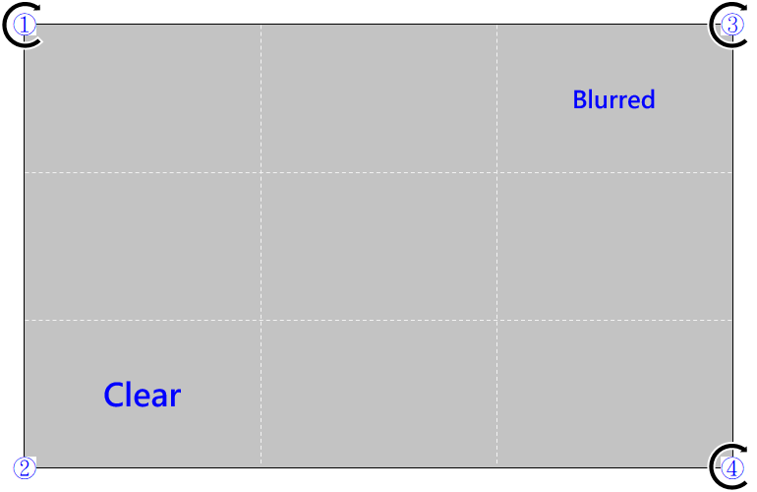
- Resetting boresight.
  - Mount the lens onto the lens shift module, and tighten the four boresight screws evenly counterclockwise.
  - Loosen the tightened screws by two turns in a clockwise direction.
  - To check for a screen unbalance, select and hold Focus key until the first clear corner is identified.
  - Adjust the boresight screw counterclockwise for negative unbalance and clockwise for positive unbalance (see the figure below).
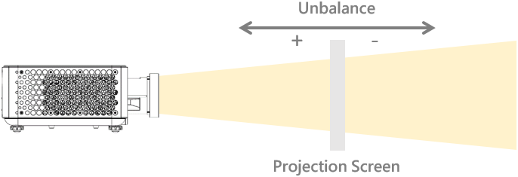
  - For the left-right adjustment, follow these steps (see the figure in step e) for image zones.
    - Approach the screen and if A, D, G is clear, examine C, F, I for unbalance (see the figure above).
    - Adjust the focus for C, F, I with a negative unbalance.
      - Turn screws ① and ② clockwise a 1/8 turn, and screws ③ and ④ counterclockwise a 1/8 turn
      - Observe if the image is clear.
      - If it is not clear, check the unbalance and clear the area.
    - Adjust the focus for C, F, I with a positive unbalance.
    - Turn the screws ① and ② a 1/8 turn, and screws ③ and ④ counterclockwise a 1/8 turn.
    - Repeat steps a to d until the image is clear on both the left and right sides of the image.


Operating the UST lens
To achieve optimal performance, the UST lens is equipped with two motors for focus control: ‘Back Focus’ and ‘Focus’. Users can adjust the focus using the remote controller or keypad. Follow the steps below:
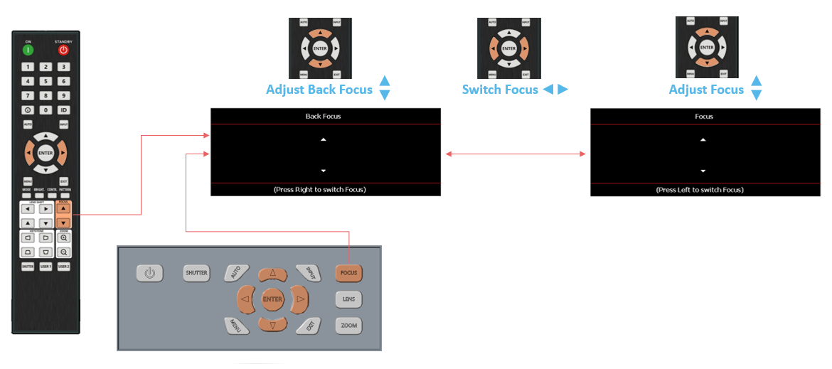
  - Back Focus: Adjusts the entire screen focus (center + corners).
  - Focus: Primarily adjusts the corner focus (the center may shift slightly).
Operation Steps:
- Press ‘Back Focus’ to adjust the entire image (①).
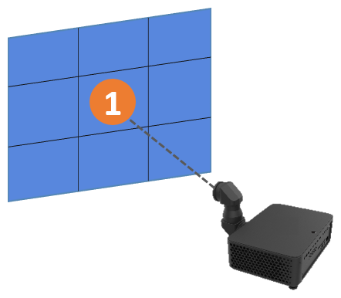
Note: Focus on the part of the image closest to the lens, usually the center of the screen.
- Press Focus to adjust the surrounding area (②).
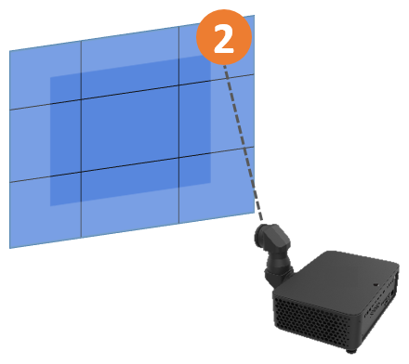
Note: Focus on the part of the image farthest from the lens, typically the corners of the screen.
- Press Back Focus again to fine-tune the overall focus (③).
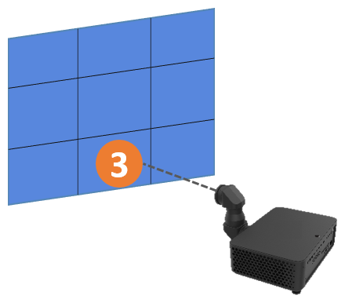
- If the image is still not clear, repeat Steps 1 to 3 until both the center and corners are in focus.

Remove the UST lens
- Please refer to Step 3 of the UST lens installation to move the lens shift module to the topmost position.
- Please refer to Step 2 of the UST lens installation to loosen the two plate screws.
- Insert the S-shaped hook into the designated hole on the plate.
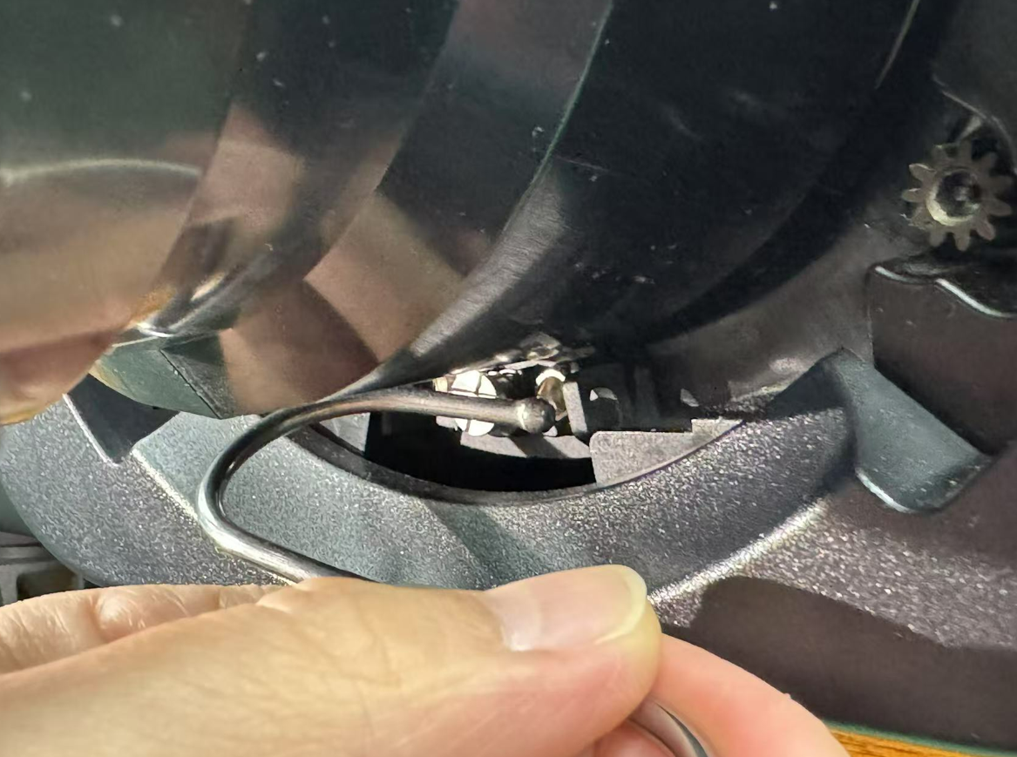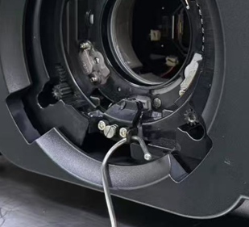
- Hold the lens with your left hand and support the bottom with your right hand. Use your right-hand fingers to hook the S-shaped latch and gently pull it outward to unlock. Then, carefully rotate the lens counterclockwise about 35 degrees with both hands to remove it.
